St. Ann School
Parent / Student Handbook
2022-2023



Saint Ann School
125 Cromwell Avenue
Staten Island, New York 10304
718-351-4343
www.stannschoolstatenisland.com

Dear Parents,

This handbook is issued by the Administration of Saint Ann School to promote a closer relationship between the parents and the school. It is suggested that it be kept on hand as a source of reference.

The staff of Saint Ann’s is dedicated to the task of providing an educational program designed to help each child achieve maximum growth in his/her spiritual, physical, mental, academic and social development. We hope each student will assume his/her place in the community as a dependable, intellectually curious Catholic and citizen.

Sincerely,
Bernadette A. Ficchi
Principal

Policies

Academic Expectations

Saint Ann School expects students to perform to the best of their ability.
Teachers are expected to evaluate student progress on a regular basis. Students will be given quizzes or tests regularly. After the test is graded, it will be sent home for the parent/guardian to review and sign. A parent/guardian’s signature indicates that the parent is aware of the student’s progress.

Graduation

At the discretion of the principal, each school has the right not to certify the student's
graduation or provide transcripts of the student's academic record to third parties such
as other schools, colleges, or employers, or to issue a diploma to the student, if there
has been a breach of a material condition of this educational contract (i.e., failure to
meet financial obligations, infractions against the school’s code of conduct, etc.).

Homework

Homework is an essential part of the instructional program, reinforces learning, and provides students with opportunities to practice what they have learned. This practice helps students establish good study habits, become independent learners, and strong readers, writers, and mathematicians. All homework times include 15 minutes of reading or being read to

The time allotments for homework (written and study) are as follows:
Grades Pre-K & K short homework assignments related to the curriculum
Grades 1 & 2 approximately 30 minutes
Grades 3 & 4 approximately 45 minutes
Grades 5 & 6 approximately 90 minutes
Grades 7 & 8 approximately 120 minutes

Students are required to complete all homework.

Homework ideas for your child:
1. Cooperate fully with the teacher.
2. Provide a suitable work space (table, light, supplies, etc.)
3. Set a definite time for doing homework.
4. Turn off the TV and any other distractions.
5. Show an interest in your child's work, but do not do it for him.

Grades and Grading

Report cards are distributed four times a year for Grades 1 to 8. Pre-K and
Kindergarten Report Cards are distributed four times a year. The report card is an important part of the ongoing communication between the school and the home. Dates for progress reports and report cards are on the school calendar.

Academic Achievement

The first part of the Archdiocesan Report Card is used to mark the student’s achievement in academic subjects.
- The achievement mark is based upon the demonstration of mastery of material covered in class such as:
- Summative Assessments
- Formative Assessments
- Quizzes
- Classwork/participation
- Homework
- Projects/portfolios

There are no grades for Computer Science or Library as this area is to be supportive of, and integrated into, the total learning process.

Foreign Language will be given a letter grade if the class meets for less than 120
minutes per week. Foreign Language will be given a numerical grade only if the
class meets for more than120 minutes per week. The Final Report Card Grade is
the weighted average of the four previous quarter grades, with the mid-year and
end-year tests in Religion for Grades 3 -5 and in all core subjects for Grades 6-8.
This Final Grade will be recorded on the student's permanent record.

- Numerical marks are recorded on report cards for Grades 1 – 8.
- Kindergarten Report Cards will continue to use Progress Codes and Standards.

- The marks are an average of summative assessments, quizzes, classwork, homework, and formative assessments.
- Passing is any mark 70% or above for Grades 1 – 8 or any mark of D or higher.
- Grades 1-8 will sit for midterm and final exams.
- Parent/guardians should be informed in a timely manner in the event of a student who is not satisfactorily performing in a course or activity.
- Parent/guardian are encouraged are encouraged to monitor child’s progress by using the Educate portal.
- A student will not sit for a midterm or final unless all financial obligations have been met.

Character Development

The Conduct and General Effort Scale indicates grades for General Effort and Character Development. A single letter grade is used with progress codes indicating improvement needed in any sub-category.

Honor Roll

The Honor Roll for St. Ann School pertains to all students in Grades 3-8. The criteria for Honor Roll status is as follows:

Academic Circle of Excellence: for 8th Grade only-
those students who achieve a 95 or
higher in every subject, and all A’s in
minor subjects and conduct.

Principal’s List: 95% average; 90 or above in all subjects;
All A’s in minor subjects and conduct.

First Honors: 90% average; no grade less than 90;
All A’s in minor subjects and conduct.
Second Honors: 85% average; no grade less than 85;
A’s or B’s in minor subjects and conduct.

National Junior Honor Society Students are eligible in 7th and 8th grade. Admittance is determined by achieving an 85 or above average and no grade lower than a B. It is determined by the first quarter grades. Students must fill out a form and be accepted by the committee. Failure to follow the tenants of the NJHS will result in expulsion from the club.
Progress Reports

Progress Reports are distributed midway between each quarter.
The teacher will notify the parent in writing if the child is in danger of
failing or failing a major subject area before the report cards are distributed.

Report Card Distribution

Report cards are distributed according to the school’s designated calendar. Report cards will be withheld if financial obligations have not been met and fees are outstanding.

Graduation in both grades K & 8 will not take place until all financial obligations are satisfied.

Retention/Promotion

Very few decisions we make about children are more important than recommendations to promote or retain a student. When a school accepts a student, that school accepts the responsibility for providing appropriate instruction to help the student achieve the prescribed goals. If the student successfully achieves the
program’s objectives, the student progresses to the next level.

Testing, diagnosis, and actual performance, however, may indicate that some students cannot follow the school’s complete course of study. The principal and school faculty develop for each of these students a special program, based on the school’s regular program, which follows the New York State Standards. A copy of the student’s modified program is retained in the student’s file. Conferences must be held with the parent/guardians to periodically to inform them of the specific demands of this program and on-going progress. Therefore, the decision to retain a student presupposes that the school has done everything to help the student achieve success, and the student still has not made satisfactory progress.

If a student is being considered for retention, teachers must begin discussing this possibility early in the school year with the principal. Parent/guardian conferences must be held periodically, and notification of the possibility of retention must be made no later than mid-January, with written notation having been made on the report card. Although the teacher consults with the principal, the final decision for retaining a student rests with the principal.

The following are specific criteria that will assist teachers as they consider a recommendation for retention.
The student has failed to pass the major subjects on each grade level.

The following table indicates the specific failures by grade level that might result in retention at that grade level:

Level | Academic Performance
Kindergarten | Evidence that the child is not meeting program expectations.
Grade 1 | Evidence of insufficient developmental progress and a failure in ELA.
Grade 2 | Failure in ELA.
Grade 3 | Failure in ELA and mathematics.
Grade 4,5,6 | Failures in ELA, and mathematics, or  Failures in ELA or mathematics and failures in two of the following subjects: religion, science, and social studies.
Grades 7,8 | Failures in ELA and mathematics or  Failures in ELA or  Failures in ELA or mathematics or failure in one of the following subjects: rel., sci., social studies.

The student has not demonstrated acceptable progress toward mastery of standards. The following types of behavior might indicate unacceptable progress:

- failure to complete assignments
- failures on multiple summative assessments
- repeated scores of 1 (“below standards”) in several standard domains on report card
Generally, a student would be retained only once in the elementary grades (1 - 5), and only once in the upper grades (6 - 8).
If a student completes all requirements for promotion or graduation, a family cannot self-select the student to be retained in their grade.
Assessments

In addition to class and school exams, every student will take part in the Archdiocesan testing program which includes the Archdiocesan religion tests, interim assessments, and New York State Education Department assessments. All students enrolled at our school are expected to participate in all exams and assessments. No alternative assessment will be provided. If the parent/guardian refuses to allow their child to participate in the New York State Education Department Assessments, their child will not be permitted to attend school on the testing dates.

Archdiocesan Test

Religion Test- mid year and final exams | Grade 3 to 8 | January and June
Core Subjects- mid and final year exams | Grades 6 -8 | January and June

In June, the Archdiocesan Religion exam will be used as the student's End-Year Examination in Religion for Grades 6-8.

Interim Assessments

Interim Assessments – Administered Three Times per Year
Grades K-8 | NWEA MAP Interim Assessments

NY State Tests
New York State Exams
Grade Tests
3 English Language Arts and Mathematics
4 English Language Arts and Mathematics
5 English Language Arts and Mathematics
6 English Language Arts and Mathematics
7 English Language Arts and Mathematics
8 English Language Arts and Mathematics

The faculty of the school reviews these test results regularly for the purpose of fostering student growth and achievement.

Accidents
Parents will be notified immediately when a child has a serious accident at school. It is very important for each child to have a complete and correct emergency card on file. Student accident insurance is included in the school's yearly fees. In the event of an accident at school you may obtain a claim form from the office. Please note that the school accident insurance usually is secondary to the parent/guardian’s own medical insurance coverage.

Admission Policies
Roman Catholic schools in the Archdiocese of New York base their
educational purpose and all their activities on the Christian teaching of
essential equality of all persons as rooted in God’s love.

Thus, with discrimination so repugnant to their nature and mission,
Catholic schools in this Archdiocese do not discriminate on the basis of
race, color, national and ethnic origin, or gender in administration of
educational policies, admission policies, scholarship and loan programs,
and athletic and other school administered programs.

This policy is subscribed to by all Catholic elementary and secondary
schools in the Archdiocese of New York whether owned or operated by
the parishes within the Archdiocese, Catholic School Regions, or religious
communities with the Archdiocese.

The process for admission to Saint Ann School is: parent/guardians must
complete the school application form and provide all required documents. This
application is found online and is processed through TADS admissions.
Following an interview and evaluation of the materials, the parent/guardian will be
notified through email about the status of the child.

While admission is on a first come, first served basis, the school endeavors to give preference in admissions, following these guidelines: first, to siblings of currently enrolled students; second, to Catholic students whose parent/ guardians are active members of the parish or active members of a parish in the region; and third to non-Catholic students.

After Care Program
An After Care Program is available to parents/guardians. It runs every day until 6 pm. Each session will be supervised by an adult staff member. Homework help and activities will be incorporated. Please call the office for more information on fee schedules. Emergency care will be available. If the parent cannot pick up their child from After Care, the child will only be released to those persons listed on the emergency form. That person must be 18 years of age or older and present a picture ID.

After School Programs

After School Programs are any activity where a child in engaged in a school sponsored program. While the student is in this activity, the student is expected to follow school policy. Directors of individual activities may also issue rules of behavior, which recognizes the special nature of non-classroom activities. In instances where students are picked up, parent/guardians are expected to make arrangements to pick up their children at the end of the program or activity. Students will be released only to a parent or a person previously specified in writing by the parent. Program fees are expected to be paid in full upon being invoiced. Past due allowances will result in your child not being allowed to participate in the program until their account is brought up to date.

Announcements
Informational announcements are handled through the school P.A. system. Courteous attention is expected when any message is presented over the P.A. system, especially when prayers are said at the beginning of the day. All announcements must be written, brought to the office and approved by the principal.

Appointments
Appointments with members of the faculty must always be made in advance, before coming into school. All appointments must be made either before or after school hours and agreed to by the person you wish to visit. No adult, parent/guardian or other individual is to enter the building during school hours without checking in at the office.

Asbestos

The school building undergoes two semi-annual inspections and is continually monitored.

Attendance

In New York State, full time education is compulsory from age 6 to 16. Regular attendance is the responsibility of the child(ren)'s parent or guardian.

Excused Absence:
A child is legally absent from school for the following
Reasons: sickness, sickness or death in the family, impassable roads or extreme weather; all other absences are unexcused.

Lateness:
A child should come to school even though he/she may be late. All lateness is recorded and marked on the record card. Parents will be consulted about chronic lateness and the child may be required to make up the time missed.

When the child returns to school, from an absence, a completed absence form must be given to the teacher. (See Appendix) This form is distributed at the beginning of the school year and contains appropriate spaces for the child’s name, date of absence, class, reason for absence, and the signature of the parent or guardian.

Doctor or dental appointments should be scheduled for after school or on Saturdays. Family vacations are not to be planned for those days when school is in session. The school provides families with an annual calendar to ensure that does not happen. If it is necessary for a child to be dismissed during the school day, the parent or adult, must be 18 yrs. of age or older, chosen by the parent MUST come to the school for the child. The school must be informed ahead of time about such occurrences.

When a child is absent, parent/guardians are required to phone the school. Absence notes are still required in addition to the phone call. Excessive absence and lateness may be considered educational neglect.

Birthday Parties
Birthday parties for Grades Pre- K – 3 may be held monthly in each homeroom
with the teacher’s permission. Parent/guardians should notify the teacher in writing.
Parent/guardians may bring small individual items such as cupcakes, brownies, etc.
Parents may not bring in favors or “goodie” bags for the students. Please be aware of children who may have allergies and send in only those items that are peanut free.

Books
All resource materials chosen for use in academic courses must be consistent with the religious nature of our schools. Books, DVDs, or other electronic based supplementary resources that contain profanity, inappropriate sexual references, and other immoral information would be in violation of this policy. All books must be properly covered. Contact paper is NOT to be used to cover any books obtained under N.Y.S. Textbook Loan. These books are stamped on the inside front cover. Each child is responsible for keeping his/her books in good condition. Books that are lost or defaced become the liability of the student and his/her parents. If a book is lost or defaced, the school will bill the parents for the cost.

1. ASSIGNED TEXTBOOKS: When a textbook is lent to a pupil on a semi-
permanent basis, the New York State Department of Education requires
that:
  - the pupil’s name be placed in the space provided in each book
  - the teacher make a record of the number of the book
  - the teacher make a record of the condition of the book
d. In September, each child will put a clean cover on each
textbook received. In June, all textbooks are collected,
extra materials and covers are removed.

- SUPPLEMENTARY BOOKS:
When books are handed out to the children for use during a specific period within the classroom, they will be immediately collected after they have been read. If the book is to remain with the children for any length of time, his/her name must appear in the book and the teacher should have a record of this.

- LIBRARY BOOKS:
Books may be borrowed for two weeks. Books are charged to the child so that he/she will have the experience of signing out a library book and abiding by due dates. If books are returned late, there will be a five cents fine per day per book, payable by the child. All lost library books must be paid for so that the school can purchase a replacement copy. If the book is located after a new order is placed, the child will be allowed to keep the old book since he/she has paid for it.

Buses

Busing is provided within a 15-mile limit to students from their residence. The public school district where the student resides provides and manages this service. If a student is to take a different bus from school a note must be submitted to the principal at the beginning of the school day.

To obtain student transportation in school districts outside of New York City, parents must file requests with the district in which they live by April 1 of the preceding school year or within 30 days of moving to the district. Parents must contact their local public school district to determine their eligibility.

Students and parents should consider riding on the school bus as a privilege and an extension of the school. Thus, students are to demonstrate a respectful, Christian, and safety-conscious attitude at all times on the bus.

- Students should obey the driver and monitors at all times.
- Students should do nothing to cause annoyances or distraction to the driver, as this places the safety of all in danger.
- In cases of extreme or persistent misbehavior, Saint Ann School will work in consultation with the public school district about possible consequences.

Change of Address, E-mail, Phone

The office must be informed immediately if there is a change of home address or
telephone number for purposes of mailing and/or emergency.

It is most important that all working parents list their place of employment and
employment telephone number with the school office. It is also important for a working
parent to list with the school office the name and telephone number of a relative, friend
and/or neighbor to be contacted in case of emergency. Please be assured that these
telephone numbers will be kept confidential and on file in the school office only.

Charter for the Protection of Children and Young People
- All institutions and programs of the Archdiocese will comply with the Safe Environment Policies of the Archdiocese.
- The Department of Education has developed a curriculum for the children in our parishes and schools, entitled “Right, Safe, Good Relationships”, which provides age-appropriate instruction in child sexual abuse. The lessons in this curriculum must be given annually to all children in all grades.
- Parents reserve the right to remove their children from the classes. The school administration should take care to cause as little embarrassment of these students as possible.
- If parents choose not to have their child participate in the safe environment classes, the parents will be offered training materials, and will be asked to sign a form acknowledging that the materials were made available to them. This form will be maintained in the records of the school. If the parents decline to sign such a form, a notation of this will be made in a record maintained by the school.

Child Abuse Laws
Under NYS law, school officials are responsible for reporting any suspected cases of child abuse or neglect to the proper agency. In so reporting, no allegation is
made against a parent or care giver. Rather, it is a judgment by the school that
the child may be presenting signs of abuse or neglect. If the principal, teacher, or school nurse suspects abuse or neglect, he or she must report the alleged abuse to the proper agency.

Child Custody
At the time of school entry, or at any other time when a change in custody status/arrangements occurs, it is the responsibility of the parent(s) to provide the principal with a copy of the legal document from the parent for any student for which there is a legal custody agreement or for any student not residing with his/her parent.

School communication with the appropriate guardian is essential. Accordingly:
- Custodial parents must identify in writing other adults who may have access to information regarding their child.
- Non-custodial parents may receive information(when requested) regarding the child unless specific documentation to the contrary is provided in the legal custody agreement.

Non-custodial parents may pick up a child only if written permission has been granted by the custodial parent.

Communication

Since as parents you are the child’s first teachers, you are our partners in
education. Therefore, regular communication with you is an essential part of your
child’s school experience. Scheduled parent conferences allow teachers and
parents to discuss student achievement as well as to develop means to assist
students in areas of difficulty.

A parent may request a meeting with a teacher at any time by simply sending a
note to the teacher in question and the teacher will arrange for this meeting
outside class time at a mutually convenient time. The meeting should take place
in the classroom or someplace that ensures privacy, never in a hallway or on the
street. A parent who is refused such a meeting should notify the principal.

Parent-teacher conferences will be scheduled each year in conjunction with report card
distribution to provide an opportunity for in-depth discussion of student growth. Parent-
teacher conferences are required at the end of the first marking period. Teachers are
expected to be reasonably available to parents throughout the school year in order to
keep open the lines of communication in the best interest of the students.

Conduct and Courtesy
Courtesy and good manners should be the key to a student’s conduct at school. A good attitude toward teachers and fellow students will make school enjoyable for all. Students are expected to have respect for school property and to take good care of books, desks and other furniture and equipment.

Confidentiality
There is a professional, legal, and moral ethic that requires all persons to safeguard all
information of a privileged nature.
It is imperative that such information be regarded as a sacred trust.
- if there is evidence of knowledge that could impact on the health or safety of any person, the teacher has the responsibility to share the information with the principal.
- under Section 423 of the Child Protective Services Act, school officials are required to report when they have reasonable cause to suspect that a child coming before them in their professional or official capacity is an abused or maltreated child. (See section on Child Abuse.)

The rules that govern privileged information apply, as well, to any personal or
academic information that is discovered through daily classroom instruction or
other social interaction with students, parents or peers. Always the sense of the
confidentiality should prevail.

Contacts with the Media

Parents have the right to exclude their children from videotaping, audio recording, school pictures, other photography or participation involving printed materials or on the Internet. Parents should provide such documentation to the school office, otherwise, they must fill out the media authorization release form. If enrolled in a regional school, this media authorization release was imbedded within the online registration process. A written form is not required unless a family wants to change their preference. Parents of students who enrolled in Universal PreK should fill out the media authorization form.

Crisis/Emergency Information

Should a crisis require evacuation from Saint Ann School building,
students will be brought to the Church. Our 2nd alternate site is P.S. 11. Parents can meet their children at these locations. Saint Ann School uses the Iris Alert System to notify parents directly about the crisis.

For further information concerning the crisis, parents can refer to the following:
Radio | On the Dial | On the Internet
WOR | 710 AM | www.wor710.com
WCBS | 880 AM | www.wcbs880.com
WINS | 1010 AM | www.1010wins.com
WADO | 1280 AM (Spanish)
WPAT | 93.1 FM (Spanish) | www.lamusica.com
WSKQ | 97.9 FM (Spanish) | www.lamusica.com

Curriculum Development
The Curriculum Guidelines issued by the Archdiocesan Education Department Essentials of Learning, the State Department of Education of the University of the State of New York, and the Common Core Curriculum serve as the basis for the curriculum developed at each local level to meet the particular needs of the students.

It is understood that, in accord with the Christian philosophy and goals of the Catholic schools, religious education and course in Christian family living are essential and integral components of the curriculum

\

Daily Schedule
The following schedule will be observed by Grades K - 8:

7:45 AM  7:50 AM | Enter Auditorium  Walk to Classrooms
7:55 AM | School Begins
11:25 -12:00 | Lunch
12:00 -12:25PM | Recess
2:30 PM | Dismissal

Before 7:45 AM and after 2:30 PM Saint Ann School does not have staff
available to watch out for problems on school grounds or to supervise children
on school grounds. Students should not arrive on the school grounds prior to
7:45A.M. and parents must arrange pickup at dismissal times. IN THOSE INSTANCES
WHEN STUDENTS ARRIVE ON THE SCHOOL GROUNDS PRIOR TO 7:45 AM,
PARENTS MUST PROVIDE FOR THEIR PROTECTION AND SUPERVISION.
To avoid interruption during the school day, any messages, forgotten lunches,
books and boots, etc., must be taken to the OFFICE and not to the classrooms.
The school office will see to it that the child receives these items.

Discipline Code for Student Conduct
The goal of discipline in a Catholic school is for students to learn self-discipline, which strengthens and promotes the values incorporated in our Catholic faith community. As the school builds community, it develops in students the awareness that sensible rules serve to safeguard the individual's freedom and provide an atmosphere conducive to learning. Disciplinary measures should have as an end the development of the human person who respects one's self, other persons, and those in authority.

By enrolling a child in this school the parent agrees to be supportive of the rules and regulations that we deem as critical in the spiritual, academic, and behavioral growth of the child.

Teachers discipline students directly for minor classroom disruptions (i.e., not coming prepared to class; not being in the complete school uniform; not completing assigned homework; minor verbal disputes with other classmates; etc.). Parents are notified of the problems by the classroom teacher and are asked to help the teacher to insure that inappropriate behavior is modified.

Teachers are not permitted to use corporal punishment on any child. Perceived acts of corporal punishment should be reported to the principal of the school immediately by students and/or parents.
It happens that some classroom discipline issues are referred to the administration of this school. This would include chronic minor problems listed above or major problems (i.e.

chronic lateness; verbal abuse of the teacher by the child; signs of disrespect to a teacher or another adult on the staff; fighting; physical, sexual, or verbal harassment, or bullying of a fellow student; violent behavior; stealing; smoking; vandalism; or the possession of drug paraphernalia, cigarettes, drugs, alcohol, dangerous items or a weapon). The administration handles such matters in a variety of ways depending on the severity of the incident.

The school employs a progressive discipline system for minor acts of misbehavior in order to encourage students to change inappropriate behavior so that sanctions do not increase in severity. For acts such as missed homework, disruptive classroom behavior, etc., students are often given detention and demerits.
Repeated violation of these rules and regulations may result in suspension from school or the non-re-registration of the child for the next school year.

For more serious acts of misbehavior such as, but not limited to, fighting, stealing, vandalism, and harassment, the student is immediately suspended for a period of one to five days. In cases of vandalism, the parent must pay the full cost of the repair or replacement of the item before the child may return to school. In cases of theft, the item is either returned in good condition or the cost of replacement is borne by the parent before the child can return to school.

In cases where a child engages in a fight which causes injury to another child or adult, the police may be summoned and, then, the parents will be notified. Likewise, the possession of drugs or alcohol by a child is reported to the police. The school reserves the right to request an expulsion from the Superintendent of Schools for such an offense.

In cases in which a child brings a weapon to school, the police are summoned, and then the parents are called. The school reserves the right to request expulsion by the Superintendent of Schools for any serious offense.

Individual-directed threats of violence or harm communicated directly or indirectly by any means, as well as building-directed threats of violence or harm communicated directly or indirectly by any means (e.g., shooting, bomb threats), or to harm students, employees, or visitors are taken seriously. Upon knowledge of the threats, the principal will notify the Regional Superintendent and call the parents. The Office of the Superintendent will also be notified and, along with administration, will determine the course of action to be taken up to and including calling law enforcement, requiring a mental health referral and/or expulsion.

It is the expectation of this school that student behavior is exemplary both on and off school grounds. A student always represents the entire school community. Therefore, the school reserves the right to discipline students for acts such as, but not limited to: stealing, fighting, vandalism, bullying or any other type of threatening or inappropriate misconduct (personally, via telephone, or the internet). Such misconduct could result in punishments including suspension and /or expulsion.

Lastly, a child’s arrest for a crime on or off of school grounds, within or beyond the
vicinity of the school, at any time could result in the child’s suspension or expulsion. A child’s conviction of a crime on or off of school grounds, within or beyond the vicinity of the school, will likely result in a child’s expulsion.

Dress Code

Your school uniform confirms your attendance at Saint Ann School and is a symbol of unity within the school community. It minimizes distractions in the learning process. It is important that you take pride in your appearance by wearing your complete uniform always remembering that by wearing it inside and outside the classroom and the school you are representing the school and your behavior should be a credit to both yourself and the school community.

Winter Uniform:

Girls: K-5: Jumper, short-sleeved white uniform blouse with round peter pan collar

and a plaid cross over tie, gray socks, uniform shoes.
6-8: Skirt, vest, and short-sleeved white uniform blouse with a pointed collar,
gray socks, uniform shoes.
Boys: K-8: gray pants, short-sleeved white shirt, plaid tie, black or gray socks,
uniform shoes, gray/black belt.

Boys and Girls are permitted to wear the uniform gray sweater with the school logo from November until March. There is also a navy blue cardigan with the school logo that can be worn in place of the sweater for Grades K - 8.

- Students MUST be in complete uniform from the FIRST DAY of school to the LAST DAY. Please check the size of the uniforms and shoes during the year and replace them as needed. Growing children usually cannot wear the same clothes and shoes for a full year. It is the parents’ responsibility to see that the uniform and shoes fit properly.
- NO PART OF THE UNIFORM may be bought anywhere but at the recommended dealers.
- Gym suits for both boys and girls (K to 8) must be purchased from the school supplier. NO WHITE SOCKS ARE TO BE WORN BY EITHER BOYS OR GIRLS EXCEPT ON GYM DAYS!! BOTH BOYS AND GIRLS ARE TO WEAR A SAINT ANN’S SHIRT under their Saint Ann’s sweatshirt.

Gym Uniform:
Red school uniform shorts, gray sweatpants and sweatshirts with the Saint
Ann School and Patriots name on them, and plain white sneaker. If a student
does not have the proper sneakers, he or she will not participate in gym.
Girls and Boys:
The presence of anything that proclaims a current fad is not permitted.

- School sweaters and the school cardigan are the ONLY sweaters to be worn. They will then be worn until the end of March. From September to November and from March to June the sweaters will be removed and put in the clothing closet. Please be sure that all articles of clothing and have your child’s name on them.
- BOYS ARE FORBIDDEN TO WEAR EARRINGS-even on Dress Down Days.

BOY’S HAIR MUST BE ONE INCH ABOVE THE SHIRT COLLAR. NO HAIR on the ears or the forehead. Parents should see their children as they leave for school! Hair styles that are forbidden include ”spikes”, “comb overs”, “shaved lines”, “mohawks”, "man buns", and any other type that is EXTREME OR EXAGGERATED. Children should be more concerned with their school work than their hairdos.

Girls must wear their hair in a simple, neat style, and for health reasons, it should not be on the face. Bows, “yarn ties”, fancy hair ornaments are not permitted. No ombre, no highlights, no lowlights, koolaid dyed tips. NO MAKE-UP of any kind is to be worn.
NO EARRINGS, if the ears are pierced, just small gold posts may be worn. No extra piercings. ALL other earrings and jewelry will be confiscated. No charm holders around the neck…..only miraculous medals or simple crosses. NO NAIL POLISH and NO TIPS.

- In order to insure student safety, we reserve the right to inspect and search all personal property brought into the school.

- No bracelets, silly bands, or wide rubber slogan bracelets are permitted on either boys or girls. The only wrist adornment that is allowed is a watch or a saints’ bracelet.

Summer Uniform
Girls: Blue skort and white polo shirt with school logo- younger grades K-5.
Uniform skirt with polo shirt for girls 6-8
White anklet socks- No Low cut Socks
Regular school shoes

Boys: White Polo Shirt with school logo
Gray school pants, gray socks and black/gray belt, uniform school shoes

Personal Appearance

A good personal hygiene routine should be followed daily: ears, neck, and fingernails should be given special attention. When appropriate, children should be instructed in the use of deodorant.

Uniforms should be neat and clean.

Hair should be clean and well groomed. Bangs should not be so long that they impede vision.

Parents will be notified if a child comes to school consistently in an unkempt manner. If no improvement is noticed within a reasonable amount of time, an appointment with the parents and the principal will be arranged. If the child is consistently out of compliance with the Personal Appearance Policy, detention will be given to the child until they comply with the school's directives.

Drug and Alcohol Policies

In recognition of the seriousness of drug and alcohol problems to which the
children are exposed, Saint Ann School will follow the policy as stated below:

If a teacher suspects that a child is under the influence of either drugs or alcohol, the matter will be referred to the principal immediately.

• The principal will verify the teacher’s observation and will notify parents,
• If the student confirms suspicion or appears unstable, student should be brought to the attention of the School Nurse (as per the Emergency Guidelines)
• If necessary, the principal will call 911 (as per the Emergency Guidelines)
• The police may be called if the student is in possession of an illegal substance (as per the Emergency Guidelines),
• Parents must pick up the child immediately should it be determined that the suspicion is founded. Parents will be expected to follow the recommendations of the school principal if the child is to continue in the school; and
• Any student who appears to be under the influence of alcohol or any drug, drug, and appears at a school function in questionable condition, will be barred from attending or participating in that ceremony, a party, dance, or school outing. Parents will be notified and appropriate action will be taken, which may include suspension or expulsion from the school.

Electronic Devices
Electronic devices may be dynamic tools in the 21st century school environment, but only when used appropriately by faculty, staff, administration, and students.

The use of electronic devices by faculty, administration, staff, and students must be appropriate to the educational setting, and may not distract the student, other students, or the class as a whole during the course of the school day and after school. (i.e., cell phones, tablets, Smart phones, and other personal electronic devices.) In the event an electronic device, including a student cell phone, is believed to contain evidence of a violation of school policy and/or a threat to the school community, the individual possessing the electronic device is obliged to grant the administration of the school access to the device and the information on the device to ensure compliance with policy and the safety of the school.

All cell phones and tablets will be collected by the homeroom teacher and placed in a secure location in the office, and returned at the end of the school day. If that child fails to hand in the cell phone at the stated time, a $25 fee will be incurred in order to get it
back. This money will go to the missions. The device will be held in the office until the weekend.

Inappropriate use of any electronic device may result in serious consequences as stated in the school’s Technology Use and Policy Guidelines. See Appendix.

Emergency Closings/ Delayed Openings
- Saint Ann School in the Archdiocese of New York will follow the policy of local public schools when closing due to inclement weather, loss of power or other issues.
- In addition to the following the lead of New York City Public Schools, Catholic schools in the Bronx, Manhattan, and Staten Island, may find it necessary to make closure decisions independently, based on local situations. That said, all closure decisions must be approved by the Superintendent of Schools. Schools in Westchester, Putnam and the Upper Counties that rely on public school districts for bus transportation will follow the delayed opening and/or closing policy of the local district.
- Catholic schools throughout the Archdiocese of New York utilize the Immediate Response Information System(IRIS Alert) to notify parents directly about delayed openings and closures due to weather. The school will also post chedule changes on our website and facebook page.
- When a school in the Archdiocese is closed for the day due to inclement weather or other unforeseen situations, the following will apply:
- All school related extracurricular activities, interscholastic contests, team practices, and field trips will be canceled.
- After school and extended day programs will be closed all day.

Expectations and Responsibilities for Students
Students attend Saint Ann School in order to develop fully their God-given talents and capabilities. To accomplish this, students are asked to:

- do their best work at all times.
- treat all members of the school community (i.e., teachers, staff, priests, parents and students) with respect. This includes respecting the work of others by not cheating.
- obey all school rules and regulations, including those forbidding the use of drugs, alcohol, cigarettes or disruptive behavior.
- develop personal standards of conduct that reflect Catholic morals and behavior, and refrain from use of inappropriate language, verbal threats, and sexual behavior (including touching, gestures, writing, and dress).
- speak in a well-modulated tone of voice.
- observe the school dress code, including standards on no-uniform days.
- help care for school property and keep the school free from damage and defacement.
- report concerns to an adult, especially if they witness what they know to be a violation of the school conduct policy, violent or criminal act or become aware of a potentially violent or criminal act in school or at a school function.

Extracurricular Activities
Students are encouraged to participate in the extracurricular activities of the
school. Participation in these activities is a privilege. Students are expected to
fulfill their obligations in the classroom (class work and homework). In order to
participate in extracurricular activities, students must pass each subject on their
report card and model acceptable behavior both during the school day and during
the selected activity. Failure to meet academic or behavioral requirements will
result in the student’s suspension or dismissal from the activity. Participation in
these activities requires a commitment of both student and parent. Attendance will
be taken at each activity to determine a student’s participation. In individual cases
regarding participation in extracurricular activities, the principal holds the final
determination.

*In order to participate in CYO sports, a student must have at least a B in conduct and not failing in more than 2 subjects. Less than a B in conduct and the failure of 2 or more subjects will result in the student being suspended from the team. Reinstatement will happen when grades and conduct improve as per the principal.

Faculty Meetings
Faculty meetings are scheduled by the principal at different times throughout the year. These meetings will be posted on the monthly printed calendar in order to inform parents of the change in dismissal time. All children will be dismissed at 12 noon on these days.

Field Trips

Field trips must serve an educational purpose and their value should be an integral part of the school’s instructional program. They broaden the students’ educational experiences. Field trips are privileges given to students; no student has an absolute right to a field trip.
If there is any money owed to the school prior to the field trip, your child will not be allowed to attend that trip unless the debt is cleared.
- Field trips are designed to correlate with teaching units and to achieve curricular goals.
- Field trips vary on each grade level.
- Field trips are permissible when advanced planning, location, and the experience ensures a successful learning opportunity.
- Individual teachers in consultation with the administration reserve the right to restrict or deny student participation on any field trip due to, but not limited to, poor academic performance and/or poor conduct or behavior.
- A written official permission slip, signed by the parent, is required before a child will be permitted to attend a field trip. Verbal or faxed permission cannot be accepted. Permission slips are due in the office 48 hours before the day of the trip.
- The parent must notify the school two weeks in advance if they do not want their child to attend the field trip. If money is paid, and the child does not attend the field trip, money will not be reimbursed.
- The principal will decide what chaperones will attend the field trip with a specific class.
- It is the policy of the schools within the Archdiocese that overnight trips, trips to water parks, amusement parks, dude ranches, beaches/pools, and ski slopes are strictly prohibited.

Financial Policies

We make every effort to keep tuition and fees as affordable as possible. We also understand the sacrifice that parents make to send their children to Catholic school. The majority of the school's funding is derived from tuition and fees. The school must operate in a financially sound manner in order to provide a top quality Catholic education for each and every one of our students.

- Tuition Schedule: Grades Pre-K –

The school’s expectation at the time of registration is that all tuition and fees will be paid on time. Tuition is an annual fee that may be paid in monthly installments. Tuition must be paid directly to Smart Tuition by the designated due date. Failure to so could result in the suspension of a child for delinquent tuition or fees.

WITHDRAWALS and REFUNDS:
- If written notice of withdrawal is received by the school on or before August 15th, the entire tuition obligation will be waived, and any payments made, will be refunded upon written request to the school.
- If written notice of withdrawal is received by the school after August 15th, and the student does not attend, 90% of the tuition will be forgiven. The family is obligated to pay the remaining balance of 10% of the annual tuition as billed. If payments were made in excess of 10% of the annual tuition, a refund for that amount will be refunded upon written request to the school .
- If a family chooses to withdraw their child(ren) from the school once they begin attending, the family tuition obligation will be as follows:
Withdrawal Date | Annual Tuition Obligation
September | 80% of tuition forgiven; family obligation 20%
October | 70% of tuition forgiven; family obligation 30%
November | 60% of tuition forgiven; family obligation 40%
December | 50% of tuition forgiven; family obligation 50%
January | 40% of tuition forgiven; family obligation 60%
February | 30% of tuition forgiven; family obligation 70%
March | 20% of tuition forgiven; family obligation 80%
April | 10% of tuition forgiven; family obligation 90%
May | No adjustment; family obligation 100%
June | No adjustment; family obligation 100%
- Calculations will be based on the last month in which the child (ren) attended one or more days of school. If payment has been made in excess of the family obligation, a refund will be granted upon written request to the school.
- Student records can only be provided to the child's new school upon satisfaction of the tuition obligation.

DELINQUENCIES:

Failure to keep current with your tuition obligation jeopardizes your child (ren)'s placement in school. If tuition and fees cannot be paid on time, families must communicate with school administration in writing to prevent enforcement of delinquent tuition procedures.
- Families who are delinquent will receive a letter from Smart Tuition immediately following the due date.
- Families whose tuition payment is delinquent 60 days will receive a second letter; this letter will come from the principal. If a parent/guardian does not contact the principal within two weeks of receiving this letter, the child/children will not be permitted to attend classes.
- Failure to address the delinquent tuition payments as agreed with the principal may result in the child (ren)'s suspension.
- Records and report cards cannot be transmitted for students with delinquent tuition payments and financial aid/scholarships provided will be at risk and may be rescinded.
- Students with delinquent tuition payments may not participate in school activities and graduation ceremonies.
- Three or more failed payments within a month will result in a change of payment terms.

FEES:

Families are charged an annual $40 Smart Tuition Administration Fee upon activation of their account.
- Accounts with late payments will be assessed a late fee of $40 for each late payment.
- Checks and electronic payments that do not clear the bank will result in a $35 fee per occurrence.
- Families may be charged for other fees in addition to tuition (i.e. after school programs, meal programs, graduation, technology, home school association or other general fees.) These fees are not refundable.
- Families with accounts requiring collection action will be responsible for paying all associated collection fees, attorney's fees and costs.
- Fees are not refundable. This includes the registration fee paid through TADS.

Tuition

Pre K 3
2 half days/2 full days | $2500/$4150
3 half days/3 full days | $3570/$4760

 | Before Grants and Financial Aid | Family Grant | Total Tuition without financial aid
1 child | $5975 |  | $5975
2 children | $11,950 | -$2200 | $9750
3 children | $17,925 | -$3300 | $14625
*Remember the General Fee of $330 per child is included in this tuition. The General
Fee includes the Book Fee, Art Fee, Technology Fee, All Testing Fees, Insurance,
Educate, and IRIS Alert Fees.

Fees
There is a $40 Smart Tuition Fee per family.
New Student Registration Fee: $200
Returning Student Registration Fee: $100 if registered by May
Graduation Fee - Grade 8: $125 (payable in January)
Graduation Fee - Kindergarten: $50 (payable in January)
Family Fundraising Fee: $60 per family; payable in February; one box of chocolate.
Activity Fee (PreK 3): $200

Fundraising Activities
Saint Ann School has two mandatory fundraisers. The Candy Sale where each family must purchase one box of chocolate valued at $60. This will appear on your Smart Tuition Statement in January. The Calendar Raffle is also a mandatory fundraiser where each family must sell ten calendars at a value of $10 each.

Your participation in ongoing religious, educational, and voluntary programs of our school is vital to our school and to our children. We thank you for your cooperation and support that you give to Saint Ann School.

Fire and Emergency Drills
Fire and Emergency drills at regular intervals are required by the law and are an important safety
precaution. It is essential that when the fire signal is given, everyone obeys promptly and clears the
building by the prescribed route as quickly as possible. Students are not permitted to talk during a fire
drill and are to remain outside the building until a signal is given to return inside. Teachers will direct
the students. For other emergency drills (e.g. lockdown drills), students are expected to remain quiet
and follow teacher directions.

Guidance
A guidance program is a resource available to Saint Ann School students. Service may include counseling, psychological intervention and support for families experiencing change. The principal will be able to recommend such services if needed from an outside source.

Guidelines for the Education of Non-Catholics
Parents must be made aware of the intentional Catholic witness in our schools. St. Ann School as a Catholic school within the Archdiocese of New York has as its primary mission the formation of children in the Catholic faith.

All children will participate in total academic life of our school, including religious education. According to the norms of our Church, it is expected that non-Catholics participate as fully as they can in the liturgical and prayer life of the school.

The religious educators of our schools are committed to teaching the fullness of revelation as it is taught by the Roman Catholic Church and as the life and doctrine are set forth in the Religious Education Guidelines of the Archdiocese of New York. While our teachers value ecumenical education, and respect the traditions of other ecclesiastical communities, they always teach within the context of fidelity to the doctrine and traditions of our teaching church.

Harassment/Bullying Policies
All persons have a right to be treated with dignity and in a Catholic school environment all demeaning behavior is unacceptable. Students, parents or guardians who become aware of acts of bullying or harassment involving any student must report these incidents to the principal.

The school provides a safe environment for all and participates in the ADAPP anti-bullying curriculum annually. Verbal, internet, telephone, or written threats made against the physical or emotional well-being of any individual are taken seriously. Students making such threats, even in jest, face appropriate disciplinary action including detention, suspension, or expulsion. The principal investigates all complaints of harassment and bullying. Students determined to have been involved in harassing and/or bullying behavior are subject to detention, suspension, or expulsion and, where appropriate, will be referred for counseling services and/or reported to the local authorities.

Harassment, intimidation or bullying includes, but is not limited to, written, verbal, or physical acts, which physically harm a student or damages the student’s property or has the effect of substantially interfering with a student’s education or is so severe, persistent, or pervasive that it creates an intimidating or threatening educational environment or has the effect of substantially disrupting the orderly operation of the school. Harassment, intimidation or bullying can take many forms including: slurs, rumors, jokes, innuendos, demeaning comments, drawings, pranks, gestures, exclusion or other forms of relational aggression, or physical attacks, actions or threats. Actions may take any form including written, oral, physical or electronic.

These behaviors, which are contrary to the teachings of the Catholic Church, are prohibited in all Catholic schools in the Archdiocese of New York and will not be tolerated regardless of time or place.

No student shall be subjected to bullying and harassment on the basis of actual or perceived traits or characteristics i.e., age, color, creed, national origin, race, religion, gender, physical attributes, physical or mental ability, ancestry, political beliefs, socioeconomic status, or familial status.

HIV/AIDS Curriculum
The Archdiocese of New York and the NYS Education Department mandate that
all schools are to give age-appropriate instruction on HIV and AIDS to all students
in Grades K –12. The Archdiocesan schools use an HIV/AIDS Handbook
developed and approved by the Catholic Bishops of the State of New York.

Schools under the authority of the Office of the Superintendent of Schools of the
Archdiocese of New York do not discriminate on the basis of HIV or AIDS.
Students with HIV or AIDS shall not be excluded from school by reason of
infection with HIV unless the following conditions are evident as determined by the
student’s physician and parents (or legal guardian), together with the school
administrator and pastor. The conditions are:

- The student is not toilet-trained or is incontinent, or unable to control drooling.
- The student is physically aggressive, with a documented history of biting or harming others.

Illness (See Medication)
If a child has a chronic illness, such as asthma or a condition that warrants frequent use of the bathroom,
it is the parent’s responsibility to notify the school and classroom teacher and to provide necessary documentation and medication. Any serious accommodations must be stated in a 504 plan signed by a doctor.

The school reserves the right to call 911 in any case of a medical emergency.

Immunizations

Students are required to have all inoculations as required by the Department of Health before admission to and continued attendance at the school. See appendix for most current information published by NYC and NYS Department of Health. It is the responsibility of the parents and their personal physician to ensure that as immunization requirements change, students are kept current in their schedule.

Lateness
Student lateness interrupts the learning process for your child and all other children in
that classroom. Any student arriving at school after the published opening time is
considered late. If late, the student may be admitted to class only with a late pass
obtainable at the main office. Repeated lateness affects your child’s ability to be on the
honor role, may lead to disciplinary action, and could impede your child’s re-registration
for the coming year.

Liturgy/ Religious Education
All Catholic elementary school will follow and adhere to current Archdiocesan policies
and curriculum guidelines in religion. Students in grades 3 through 8 are required to take
Midterm Exams and Final Archdiocesan Religion Exams.

Non-Catholic students are expected to participate in the religious formation and
education programs of the school, including, but not limited to, liturgies, religious
functions, and religion classes for credit.

Parents of non-Catholic students must be willing to accept the standards, values, and
regulations of the school. They must understand and agree to the religious education
program of the school at the time of enrollment.

All students in Grades K to 8 will attend Mass on the first Friday of each month, holy
days of obligation, and at other times as indicated on the school calendar. In addition,
grades 4 - 8 will participate in one Mass per week as assigned by the principal.

Lunchroom

- Each child is assigned a seat in the lunchroom and is expected to remain in until
dismissed.
- It is the responsibility of the individual child to keep the area clean.
- Respect and obedience are to be shown at all times to those who work in the
lunchroom.
- In good weather, the children go directly from lunchroom to the play street.
- During inclement weather, the lunchroom period will be:
lunch: 11:25 - 12:00
recess: 12:00 - 12:25
- If a child normally eats lunch in school every day and will be eating out on a
particular day, a note must be presented to the teacher giving the child
permission to eat out for the day. A designated adult must pick up and
return the student within the lunch period. Telephone permission not acceptable.

Maternity/Paternity Policies

As members of the Church committed to the preservation of life at all levels, the
Catholic school must act in ways consistent with that commitment. Catholic
schools, elementary as well as secondary, are faced sometimes with the
situations of unwed mothers and fathers. The issue is certainly an emotionally
charged one. School officials will consider carefully the consequences of any
policies that are adopted. At the very minimum, students will be encouraged to
finish their work and to receive grades and diplomas. The decision concerning a
student's continued school attendance is made by the principal after consultation with
his parents/guardians, and in consideration of the best interest of the student, the unborn
child, and the school's educational expectations.

Student Abortion Policies

Rationale: The Catholic Church teaches definitively and without question that life begins at conception. Pope John Paul declared that the Church's teaching on abortion is "unchanged and unchangeable...since it is the deliberate killing of an innocent human being."

Policies:
1. If a student decides to obtain an abortion and if a school learns of it after the fact,
she will be allowed to return to school only if she accepts counseling from a
counseling program approved by the Office of the Superintendent of Schools.
2. If a student refuses counseling, she will not be allowed to continue as a student at the
school.
3. The counseling requirements stated in Policies 1 and 2 also apply to the student who is
considered the paternal father.

Guideline:
In the event a student decides to obtain an abortion despite being counseled by the school beforehand, the continued status of the student's enrollment in the school will be determined by the school administration. Factors such as the parents' role in the decision to abort should be taken into consideration.

Medications
If a student needs any kind of medication during the school day, it is the parent/guardian's responsibility to bring the medication to the school nurse, or school office, and kept there. The office will make sure the school nurse receives the medication and puts it a secure location. A written statement from the parent or guardian requesting administration of the medication in school as ordered by the licensed prescriber is required.

Medication must be presented in a properly labeled container. Prescription medication must be in the original container. On the prescription medication the pharmacy label should display:
- student name
- name and phone number of the pharmacy
- licensed prescriber name
- date and number of refills
- name of the medication and dosage
- frequency of administration

Medication should not be transported daily to and from school. Parents should be advised to ask the pharmacist for two containers – one for home and one for school. The school may receive a written request from a parent or physician to permit a student to carry and self-administer his or her own medication. Under certain circumstances it may be necessary to do so. Such a decision will be made on a CASE BY CASE BASIS and will reflect the age and maturity of the child.

- severity of health care problem, particularly asthmatic or allergic conditions
- prescriber order directing the student be allowed to carry his/her medication
- written statement from parent requesting compliance with prescriber order
- student has been instructed in the procedure for self- administration and can assume this responsibility
- parent contact is made to clarify parental responsibility in monitoring the child on an ongoing basis to insure the child is carrying and taking the medication as ordered.

Money
Money that is brought to school for a specific purpose (class trip, book fair, cupcake
sale, etc.) must be put into an envelope with the child’s name and grade and
amount. Since snacks are sold on a daily basis students may choose to bring in
small amounts of money (less than $5) for such purchases. If a student does
bring money to school the money should be kept on the student’s person and not
left in the school bag, coat pocket, lunch box, or desk.
The school cannot be responsible for lost money.

Non-custodial Parent

Release of Copies of report cards, school notices, etc.:
In the absence of a court order to the contrary, a school will provide a non-
custodial parent with access to academic records and other school
information regarding the child. If there is a court order specifying that this
should not happen, it is the custodial parent’s responsibility to provide the
school with a copy of the court order.

Non-custodial parents are generally entitled to receive duplicate sets of
report cards, school and special event notices, school calendars, etc. Such
parents might be told to supply the teacher with self-addressed stamped
envelopes for convenience and expediency.

Release of children :
Non-custodial parents may pick up a child only if previous arrangements
have been made.

Parents as Partners
Just as the parents look to the school to provide the facilities and the trained
personnel that are essential to their child’s proper development, so the school
looks to the parents to assume active responsibilities that cannot be delegated
to others.

No school can be wholly effective in teaching the values of religion and the
virtues of honesty, respect for authority, consideration for the rights and property
of others, and standards of personal morality and integrity unless these
principles have been established, upheld, and valued in the home. If parents
cooperate with the school, instill respect for the integrity of its teachers and
administration, and actively support their authority in the home, this is likely to be
reflected in the positive attitudes of their children.

Parents are asked to take an active role in their child’s education by:
- assisting their child in his/her academic and moral development by
carefully reviewing class work, test results, progress reports, and report cards; supervising home study; and reinforcing school policies.
- explaining and reviewing periodically the school behavior code with their child. Parents should discuss school disciplinary episodes in relation to the school behavior code.
- recognizing their child’s talents and interests so they may be developed in
cooperation with the classroom teachers.
- seeing that the dress code, including gym uniform, is enforced, and
insisting that children dress according to Christian virtue.
- insisting on their child’s regular school attendance and punctuality and on complying with attendance rules and procedures.
- making all tuition and fee payments on time, and participating in fundraising activities.
- providing proper supervision at home, and not tolerating harassment, inappropriate or violent behavior, or viewing of such in videos, movies,
song lyrics, and on the Internet.
- teaching their child respect for law, for authority, for the rights of others and for public and private property. This includes showing respect for the work of others by not tolerating cheating in any circumstance.
- arranging for a time and place for their child to complete homework assignments.
- working with the school in a cooperative effort to carry out recommendations made in the best interest of their child, including those related to educational evaluations and counseling.
- attending all Parent-Teacher Conferences and Home-School Association meetings.
- by always interacting in a respectful manner when speaking with or about the administration, teachers and staff of the school. Verbal or physical harassment may result in your child being asked to leave the school immediately or not being allowed to re-register for the following year.

The education of a student is a partnership between the parents and the school.
Just as the parent has the right to withdraw a child if desired, the school
administration reserves the right to require the withdrawal of a student if the
administration determines that the partnership is irreparably broken.

Parent Organizations
The Home School Association provides an effective channel of communication
between parents and the community.
Their main purposes are:
- to create mutual support and understanding between home and school, and thus bring about a total learning environment for students,
- to provide a means for keeping parents informed of school activities, programs, etc., and if any, parent service requirement,
- to assist the school in meeting its financial obligations, primarily through
fund-raising activities,
- to provide adult education programs.

Philosophy and Goals
Saint Ann School endorses the call of the Catholic Bishops of the
United States to express its educational ministry through the three objectives of
personal spirituality, social justice, and a strong academic program in accord
with Christian values. This commitment extends to building Christian community
and to fostering Christian service to the whole human family.

Re-registration

At the time of re-registration parents will be notified if their child is being invited to return to the school in September or if the child is not being invited back.

Release of Students (during school day)

The school has a sign-out book located in the main office.
- for liturgies and services when altar servers leave school; the students will sign out and in
- in the event of a student illness the parent or an adult, must be 18 years of age or older,
- designated by the parent
- must come to the school and take the child. It is against the law to dismiss a
child during school hours except into the direct custody of a parent, guardian,
or an adult designated by the parent. If the parent cannot be contacted, the
secretary will contact the name listed on the child’s emergency contact slip.
Emergency slips are completed in September and must be updated as
necessary.
- when a student is released to a parent or guardian, that adult must sign the book
- for a prearranged appointment when the student is released, the parent, guardian, or approved adult must sign the book. [Please note: only the principal may approve the release of a student for a prearranged appointment.]

Rules and Regulations
- School officially begins at 7:55 A.M.; Children walk to classroom at 7:50 AM.
- Chronic lateness will result in a step down in the character section of the report card. Chronic lateness is defined as exceeding “10 late” per semester.
- When your child is absent, it is necessary that he/she brings a note of explanation when he returns to school.
- Except in cases of injury, illness or other emergency students shall not be released from school during the school day without the prior written request of the parent and approval by the principal.
- We do not permit the chewing of gum at any time in any part of the school building or on the grounds.
- If your child forgets his/her lunch at home, do not send in McDonalds, Wendy’s, Burger King, Pizza or any other fast food lunch for your child.
- Soda, Red Bull, any other energy drink or anything in a glass container is not permitted.
- Check all backpacks and folders for important notices. Check Cornerstone for grades. Keep informed of your child’s progress. Check the website: www.stannschoolstatenisland.com to keep abreast with your child’s homework and responsibilities.
- NO RUBBER SLOGAN BRACELETS ARE ALLOWED. GOLD CHAINS ARE NOT PERMITTED. THE ONLY ADORNMENT THAT IS PERMITTED IS A MIRACULOUS MEDAL OR A CROSS AROUND THE NECK AND A WATCH OR SAINT’S BRACELET ON THE WRIST.
- BOYS ARE NOT ALLOWED TO WEAR EARRINGS IN THIS SCHOOL, EVEN ON DRESS DOWN DAYS.
- GIRLS ARE ONLY PERMITTED TO WEAR POST EARRINGS. No Nail Polish. No Tips.
- All the children are required to take part in the school activities such as fundraising, May Crowning, contests and the Christmas pageant to name a few.
- Seventh Grade parents will host and give a donation towards the Eighth Grade Prom.
- Seventh Grade parents will also serve the Eighth Grade graduation breakfast.
- First Grade parents will set up for kindergarten graduation and breakfast.
- Finally, remember we are here to educate. If you cooperate and adhere to the rules then things will run smoothly and your child will benefit.
- DRESS DOWN ATTIRE MUST BE APPROPRIATE.

Sacramental Programs

First Communion: Parents of Grade Two students will be expected to attend meetings
in preparation for their child’s reception of the Sacraments of
Reconciliation and Holy Eucharist.

Confirmation: The Sacrament of Confirmation is conferred when the students are
in Grade 7. Further details regarding the reception of the sacrament
will be sent home at the appropriate time.

School Yard Behavior
- Running wildly in the school yard is forbidden.
- The 1st bell means to stand still and be quiet.
- The 2nd bell means to proceed in silence to your line.
- The 3rd bell means to follow the teacher into the classroom.

School Calendar
Saint Ann School publishes and distributes a tentative schedule in August of each school year. A monthly calendar is also given out during the school year. Monthly events are also posted on the school’s website. The Midterm and Final Exam dates will be sent to the parents when they are finalized.

School Publications
All student or parental publications are subject to review and approved by the school administration prior to publication. The principal must have on file all current log-in information for any digital publication, email or social media accounts that represent or use the school name. Parents, volunteers and external consultants must submit any and all postings for approval in advance. Maintaining a positive public image for the school is the responsibility of the principal and Superintendant's staff.

School’s Right to Amend
Saint Ann School reserves the right to amend this handbook without prior notice. Notice of an amendment will be sent as necessary.

Security
To assure the security of the building and the safety of each child,
Saint Ann School strongly enforces its policy of requiring all visitors, even
parents, to report to the office.

To avoid interruption of the learning process, no one may enter a classroom without
permission of the principal.

The school has a crisis management manual and each classroom has a school emergencies resource book.

Sex Offender Policy

This notice is to remind you of the importance of taking steps to keep your child safe when he or she is involved in outdoor activities, including traveling to and from school. The following are some safety tips that we hope you will share with your children:
- Students should never go home with strangers.
- Students should never talk to strangers.
- Students should never take things from strangers.
- If students are approached by strangers and are still near the school,
they should be encouraged to return to the school and immediately
inform a staff member.
- Young students should be escorted to and from school.
- Older children should be encouraged to walk/travel to school in groups
whenever possible.

The teachers at our school will also remind students of the importance of not responding to strangers and actions each child should take if approached by a stranger, including reporting it to responsible adults.

In addition, over the course of the school year, we may receive from the local police department notification under the New York State Sex Offender Registration Act that a registered sex offender has moved into the region where our school is located. Copies of all the notifications we receive will be kept accessible to parents in the principal’s office. You can also find information about registered sex offenders on the NYS Division of Criminal Justice Services website, located at
http://www.criminaljustice.state.ny.us -- or by calling 1-800-262-3257.

Finally, if our school is notified during the school year that a registered sex offender has moved within the vicinity of our school, further notice will be sent to you. These procedures are part of our continuing effort to provide a safe environment for all children in this school.

Smoking

New York State Law prohibits smoking in a school building and on school property. Smoking is prohibited at all times in the Saint Ann School Building, on its parking lot
and playing fields. This prohibition applies to faculty, staff, parents, and all visitors to the school. Smoking on the sidewalk in front of the school building is not allowed. This policy includes cigarettes, cigars, pipes or any other matter or substance containing tobacco, as well as the use of electronic cigarettes (e cigarettes), personal vaporizers, vape pens, e-cigars, e-hookah, vaping devices, mod systems, pod systems or any similar system.

Special Learning Needs

Students with learning differences are children of God and members of the Church. Saint Ann School makes every effort to meet individual student needs. Sometimes, however, a student may have needs that do not permit him or her to benefit fully from the program. In those cases your child’s teacher and/or principal may schedule a meeting with you to discuss having an evaluation of your child’s learning needs. Such evaluations can be done through the local public school district, i.e., Committees on Special Education (CSE’s), or privately. Once the results of the evaluation are available the teacher and principal will meet with the parents/guardians are obligated to share educational/psychological testing results and any resulting plan with the school. The parent/guardian must make an appointment to meet with the principal to discuss the results of the evaluation and the recommendations, and provide a copy of the Individualized Education Services Plans (IESP).

If a student transfers in from a public school with an Individualized Education Plan (IEP), the parent must go back to the CSE to get an IESP.

When a student qualifies for a 504 Plan, the principal will meet with the parent/guardian to review and discuss the 504 Plan, and will then notify the parent of any reasonable accommodations/modifications that can be made at Saint Ann School. If reasonable accommodations can be made, a Student Assistance Plan (SAP) will be written and a copy of the plan will be placed in the student’s confidential file. The accommodations/modifications will be reviewed yearly. If the school cannot make reasonable accommodations, the school reserves the right to negate the enrollment of the student.

Sports Program
Saint Ann School participates in a variety of sports sponsored by the Parish of Saint Ann. ALL students, provided they meet the requirements, are eligible to participate. The program is run by the Sports Committee. Basketball, baseball, softball and bowling are offered.

Substitute (Teacher) Policy
When teachers are unable to attend class it is the policy of the school to hire only professional substitutes. However, this can only be done if the teacher’s absence is known 24 hours beforehand. As you well know illness does not always give 24 hour notice. When it is impossible to obtain a professional teacher, then and only then will we use an aide as a substitute teacher.

Summer School

Since most summer schools offer reading, mathematics, and language arts, a
student who has failed in one or more of these subjects in three marking periods of
the report card will be required to take a remedial course during the summer.
Summer school also may be recommended due to poor performance on
standardized tests or in the classroom.

In May, a list of available summer schools in the Archdiocese will be available upon
request. Whenever the administration becomes aware of quality programs suited to
the specific needs of a child, the principal or the assistant principal will notify the
parent directly.

The summer school Report Card must be submitted to the office in September.
Failure to attend summer school will result in retention. It is the parent’s responsibility
to provide documentation that summer school has been successfully completed. In
cases in which tutoring is allowed for the remediation, it must be undertaken by a
qualified teacher with appropriate documentation of lessons covered.

Telecommunications Policy

Social Media Guidelines

The principal of the school is responsible for maintaining all administrative logins for all social media outlets, blogs or any school-branded media outlets in existence now or in the future that contain the school name. Principals must be mindful that their school's social media may be linked to the Superintendent of Schools Office and the Archdiocese of New York media accounts.

All domain names and access must be owned, secured and maintained by the school principal. UNDER NO CIRCUMSTANCES are these administrative logins, permissions or oversight to be delegated to any parent, volunteer or external vendor separate and exclusive from the principal.

In addition to the login and administrative rights to the school website and all current or future social media outlets( Facebook, Twitter, Instagram, etc.) the principal is also responsible for reviewing and approving the content on such sites.

All social media content must follow the Standards of Behavior for student internet use and must reflect the standards and mission of the school.

\Student Expectations in Use of the Internet
(please see below for complete policy requiring student’s signature)

Use of School Grounds
Unless students are formally registered for before and after school programs,
the school does not have staff available to supervise students on the school grounds prior to 7:15 AM and after 2:50 PM. Students must not arrive on school grounds prior to 7:15 AM and parents must arrange to pick up at dismissal times, unless the child is attending After Care.

By order of the New York City Police Department, kindly refrain from driving and letting the students off on Jefferson Street during school time. This is a play street and closed to ALL traffic from 8:00 A.M. to 4:00 P.M. Additionally, we ask you to obey all traffic laws and especially refrain from double parking and letting your child off in the middle of the block. This is for your children’s protection. If you disregard this request you are endangering the children. The chief offenders of this law are parents of the school, especially on rainy and snowy days.

Withdrawals and Transfers
A transfer request must be obtained from the school secretary. All books must be returned. All bills must be paid before records are transferred to another school.

When a student transfers from one school to another, or enters high school, the new school may request a copy of the permanent record and health card from the former school.

Schools may disclose a student’s cumulative record (i.e. permanent record, attendance record, test results) to another school with legitimate educational interest if a written request is made and when a custodial parent/guardian has given written permission for the release of the child’s records. Parent/guardian signature is required for release of a student’s confidential file (i.e. special education records, psychological reports, disciplinary records, anecdotal information, or reports by the school counselor).

At the discretion of the principal, each school has the right not to certify the student’s graduation or provide transcripts of the student’s academic record to third parties such as other schools, colleges, or employers, or to issue a diploma to the student, if there has been a breach of a material condition of the educational contract (i.e., failure to meet financial obligations, infractions against the school’s code of conduct, etc.).

The school reserves the right to request the parent to withdraw his/her child from the school due to serious disciplinary issues.

Summary Statement

Once students have met the necessary admission requirements and have been accepted in St. Ann School, the school warmly welcomes these students for the coming school year and will strive to provide them with a solid Catholic spiritual and academic education in a supportive learning environment. Students and parents must always be mindful that attendance at St. Ann School is by invitation. It is not a “right” because this is a private school. Admission to and continued enrollment in this school include responsibilities regarding conduct, both inside and outside the classroom and school, and students are expected to conduct themselves in such a manner as to be a credit both to themselves and to their school.

In order to protect its standards of scholarship, discipline and character, St. Ann School reserves the right, and students and parents or guardians concede to the school the right to require the withdrawal of any student at any time, for any reason deemed sufficient in the sole discretion of the school and its administrators. By the student’s attendance at the school, a student and his or her parents or guardians acknowledge the important obligations and restrictions contained in this handbook and agree to be bound by the terms of this handbook.

Students attending St. Ann School relinquish certain rights they might otherwise be entitled to if they were attending a public school. For example, a student’s freedom of speech is limited in many important respects here at our school. Speech, either written or oral, contrary to the Roman Catholic faith, the teachings of the Church or the directives of the local Bishop or Ordinary is prohibited, as is any other speech which is contrary or disruptive to the philosophy and purposes of our school. Another important right all students at St. Ann School surrender involves searches and seizures. School administrators may search a student’s person and belongings if there is a reasonable belief, in the sole opinion of the school administrator, that contraband, illegal substances or inappropriate objects are being concealed. Any unauthorized items found may be seized. Additionally, student desks and lockers, which are at all times under the joint control of the school and the student to whom the desk or locker has been assigned, may be searched by school administrators at any time, for any reason or for no reason at all. Students should have absolutely no expectation of privacy with regard to any item in their desks or lockers.

Another important right that a student and his or her parents or guardians give up when they decide to have a student attend this school is the right to sue the school, the parish or the Archdiocese of New York, and/or any individuals acting on behalf of the school, such as the school administrators, teachers, staff or any of their agents for any matter relating to academic or disciplinary decisions or other matters covered within this handbook. Each student and his or her parents or guardians, by their acceptance of enrollment at St. Ann School agree to and accept the school’s rule and policy that students, parents and guardians may not bring any civil action in any local, state or federal court or in any administrative agency or body to challenge any school decision on academic or disciplinary matters, including any decision relating to the rules, regulations, procedures or programs covered within this handbook. Students and parents or guardians agree that any challenge to any school academic or disciplinary action or relating to the rules, regulations, procedures or programs covered in this handbook may only be challenged or appealed within the hierarchy of the school, subject to the limitations contained in this handbook. This includes any decision relating to a student’s enrollment at the school or termination of that enrollment.

While any student and his or her parents or guardians are of course free to consult with legal counsel regarding any school decision taken with respect to a student, the school emphasizes that students and parents or guardians are not permitted to have legal counsel present during any meetings with school administrators. School administrators are not obligated to meet with legal counsel at any time.

There are several grounds for disciplinary action or expulsion set forth in the “Discipline Codes” section of this handbook. It should be noted, however, that any listing of prohibited conduct is set forth by way of example only and to provide guidance to the student and his or her parents or guardians. It is not meant to be an exhaustive listing of improper conduct or resultant disciplinary action.

Parent Signature Page

We have received a copy of the Parent/ Student School Handbook for the 2022-2023 School Year and have read it.

The handbook is readily accessible on our website www.stannschoolstatenisland.com. If a family cannot access the website, then hard copies are available at the main office.

_________________________________ _______________________________
Parent Signature Parent Signature

Grade 2 and above: Student’s Signature
_____________________________________
_____________________________________
_____________________________________
_____________________________________
_____________________________________

Please return form by September 16, 2022.

Saint Ann School
2022- 2023

Telecommunications Policy

Student Expectations in Use of the Internet

The use of internet is a privilege, not a right, and inappropriate use or violation of any of the following standards will result in serious consequences and could result in expulsion from the school.

- Use of the computer at school is limited to school related activities. Internet users are expected to behave responsibly in accessing and viewing information that is pertinent to the mission of the school.
- Vandalism and other infractions fo school policy while using the Internet will result in immediate cancellation of privileges along with disciplinary action.
- After School/Home Access requires students to follow the same student expectations as stated in the “Discipline Code for Student Conduct” and “Harassment Policies” in the student handbook.
- Students must abide by the generally accepted rules of network etiquette both inside and outside school.
- Students are responsible for their explorations on the Internet and are subject to the consequences of the school’s discipline policy.
- Students must sign a contact indicating their understanding and acceptance of the school’s guidelines (see Parent/Student Handbook)
- Parents must give their permission for their child to use the Internet for educational purposes as an individual by signing the Contract Form once conditions are clearly understood. Parents also have the option of denying permission for their child to use the Internet independently at school.

Standards of Behavior
  - Be courteous and respectful in your messages to others.
  - Use appropriate language. Do not use vulgar, harassing, obscene, threatening, bullying, abusive, or sexually offensive language, or make any statements that are slanderous or disparaging of any students or adults.
  - Never visit inappropriate or offensive websites.
  - Never download materials from inappropriate or offensive websites.
  - Never expose yourself in an inappropriate, vulgar, or sexually offensive manner on any website or via e-mail, either in pictures or videos.
  - Illegal activities are strictly forbidden.
  - Do not reveal your home address or phone number, or that of other students or staff.
  - Note that electronic mail (e-mail) is not guaranteed to be private. People who operate the system do have access to all mail. Messages related to or in support of illegal activities may be reported to the authorities.
  - Proofread your message before you send it.
  - Never agree to get together with someone you “meet” on-line.
  - Only public domain software (“shareware”) can be downloaded.
  - Copyright laws must be respected. Do not make unauthorized copies of software and do not give, lend, or sell copies of software to others.
  - Do not use the Network/Internet for illegal activities.
  - Software applications and games from home may not be used on school equipment without the proof of licensure and prior approval of appropriate school personnel.
  - Do not reveal personal passwords, use or try to learn others’ passwords. Do not copy, change, read or use another user’s files without prior permission from that user. Do not attempt to gain unauthorized access to system programs for computer equipment.
  - Do not post personal messages on bulletin boards or “list servers” or social media platforms or send personal messages directly to the person to whom you want to write.
  - Do not use the network in such a way that you would disrupt the use of the network for other users.
  - Do not waste or take supplies such as paper, printer cartridges, and diskettes that are provided by the school.
  - Talk softly and work in ways that will not disturb other users. Keep computer work areas clean and do not eat or drink in the computer lab.
  - If students encounter material on a network/bulletin board that is not considered appropriate (vulgar jokes, statements of belief that some might consider immoral, etc.) the student is responsible for not pursuing this material and reporting the matter to appropriate school personnel.
  - The use of cell phones, camera phones or other digital media is prohibited during the school day. Cell phones, camera phones, or other personal electronic devices will be confiscated if students use them during the school day without permission. In addition, any student who uses a cameras, camera phone or other personal electronic devices in school or in the classroom for any reason will be suspended. Further disciplinary measures including expulsion, will be considered depending on the nature of the camera, camera phone, or personal electronic device use.
  - Technology use outside normal academic hours and/or off school grounds(including but not limited to cell phones, e-mail, text messages, camera phones, cameras, IPads, IPhones, chat lines, bulletin boards, etc., are subject to the same guidelines as previously cited in the Discipline Code for Student Conduct, Harassment Policies, and the Summary Statement.
  - The school reserves the right to seek financial restitution for any damage caused by a student or other user. The system administrators will deem what is inappropriate use, and their decision is final. The administration, faculty, and staff of the school may request the system administrator to deny, revoke, or suspend specific privileges. Violation of the rules and code of ethics described above will be dealt with seriously.
  - Transmission of any material in violation of any U. S. or state regulation is prohibited. This includes, but is not limited to: copyrighted material, threatening or obscure material, or material protected by trade secret. The use of school computers and networking resources for commercial activities is not permitted. Their use for product advertisement or political lobbying is also prohibited.

Telecommunications Policy
Student Expectations in the use of the Internet

Student Name: ____________________________ Grade_____________

Student Signature___________________________ Date______________

Please return to school by September 16, 2022.

One required form per student is required.

Technology Use/Telecommunications Policy
Agreement for 2022-2023 School Year for
Saint Ann School
(adapted from NCEA’s From the Chalkboard to the Classroom….1997)

Please return form to school by Sept. 16, 2022
User

I understand and agree to abide by the Telecommunications Policy/Student Expectations in the Use of the Internet agreement. I further understand that any violation of these regulations is unethical and may constitute a criminal offense. Should I commit any violation, my access privileges may be revoked, school disciplinary action may be taken, and/or appropriate legal action may be taken.

User’s name (please print): STUDENT (one per student)

User’s Signature:
__________________________________________________ Date_______________

Parent/Guardian

As the parent of this student, I have read the technology use agreement. I understand that this access is designated for educational purposes. I am aware that it is impossible for the school to restrict access to all controversial materials and I will not hold them responsible for materials acquired in use. Further, I accept full responsibility for supervision if and when my child’s use of schools technology resources is not in a school setting. I hereby give permission for my child to use the school’s technology resources and certify that I have reviewed this information with my child.

Parent or Guardian’s Name (please print)

Parent/ Guardian Signature
___________________________________________________Date _____________
Please return form to school by September 16, 2022.

________________________________________________________________________
Media Authorization and Release
2022-2023 School Year

To Whom It May Concern::

I hereby consent to the taking of photographs, movies, videos, and images capable of reproduction in any medium of me or my children or children of whom I am the designated guardian

Children’s Names and Grades:

by the Department of Education, Archdiocese of New York and/or the Catholic School Region and their parents, affiliates, trustees, directors, members, officers, employees, volunteers, agents, and contractors ("the School").

I hereby grant to School the right to edit, reproduce, use and reuse images for any and all purposes including, but not limited to, advertising, promotion and display, and I hereby consent to the editing, reproduction, use and reuse of said images in any and all media in existences and all media yet in existence including, but not limited to, video, print, television, internet, and pod casts.

I forever grant, assign, and transfer to School any right, title, and interest that I and/or my child/children have in any images, including negatives, taken of me and/or my children by School. I hereby release, indemnify and hold harmless School from any and all claims, demands, actions, or causes of actions, loss, liability, damage or cost arising from this authorization.

________________________________________________________________________
Print Name Name of Child/ Children

Signature of Parent or Guardian Date
Please return signed form by September 16, 2022

Saint Ann School

Absent Note

Student’s Name ___________________________________

Student’s Class ____________________________________

Date(s) of Absence _________________________________

Reason for Absence:

____________________________________________________________________________________________________________________________________________________________________________________________________________________________________________________________________________________________________________________________________________________________________________________________________________________________________________________________________________________________________________________________________________________________________________________________________________________________________________________________________________________________________________________________________________________________________________________
Doctor’s Note is attached. Yes No

Parent Signature _____________________________________________________________

Saint Ann School
125 Cromwell Avenue
Staten Island, New York 10304
718-351-4343
www.stannschoolstatenisland.com

NEW YORK STATE TEXTBOOK LAW (NYSTL), SOFTWARE LAW (NYSSL), LIBRARY LAW (NYSLIB),
AND COMPUTER HARDWARE (NYS CH)

PARENTAL REQUEST FORM FOR SCHOOL YEAR 2022-2023

I hereby authorize the school to obtain state-loaned textbooks, software, library materials, and computer hardware for my child____________________________who is in grade ___________ pursuant to the New York State Textbook, Software, Library, and Computer Hardware Laws.

Parent/Guardian Signature _________________________________________

Address: _______________________________________________________

Date Signed: ____________________________________________________

Please return to school by September 16, 2022.

PLEASE FILL OUT ONE PER CHILD.

Title I Participation Notice
Dear Parent/Guardian(s):
Your child may be eligible to participate in the New York City Department of Education’s Office of Nonpublic Schools Title I Program for the 2022-2023 school year, a federal program that provides supplemental educational services to eligible students at no cost to you, the parent/guardian(s). The Title I program is designed to enable all students to obtain a high quality education. Your child’s school is working with a third-party vendor to provide the supplemental educational services.
Your child may be enrolled in one or more of the Title I programs listed below
- Literacy Instruction Services | - Mentoring Services
- Math Instruction Services | - Tutoring Services
- Distance Learning Services | - Academic Counseling Service
- Additional services not listed above as determined in consultation with the Superintendent of Schools Office, Regional Superintendent and Principal.
Title I Literacy Instruction Services: Your child will receive direct instruction aimed at improving literacy skills, including but not limited to, comprehension, fluency, and writing across content areas. This service is provided in a separate location from their regularly scheduled class, other than English Language Arts, during the school day.
Title I Math Instruction Services: Your child will receive direct instruction aimed at improving math concepts and skills. This service is provided in a separate location from their regularly scheduled class, other than Math, during the school day.
Title I Mentoring Services: Your child will receive support aimed at improving academic skills, including but not limited to, communication and organizational skills. This service is provided before and after school or during non-core instructional periods. Your child will receive support aimed at improving student learning across a variety of subjects. This service is provided before and after school or during non-core instructional periods.
Title I Distance Learning Services: Your child will receive online and direct instruction aimed at improving math/literacy concepts and skills. This service is provided through a web-based computer platform before school, after school or during non-instructional periods.
Title I Academic Counseling Services: Your child will receive academic counseling supports during the school day to assist with mitigating any barriers to learning. This service is provided in a separate location from their regularly scheduled instructional periods.
Parent/Guardian(s) may be invited to attend a parent orientation meeting to further explain the Title I-funded Program. You may also be invited to attend additional workshops to assist you in supporting your child at home.

Immunization Documents
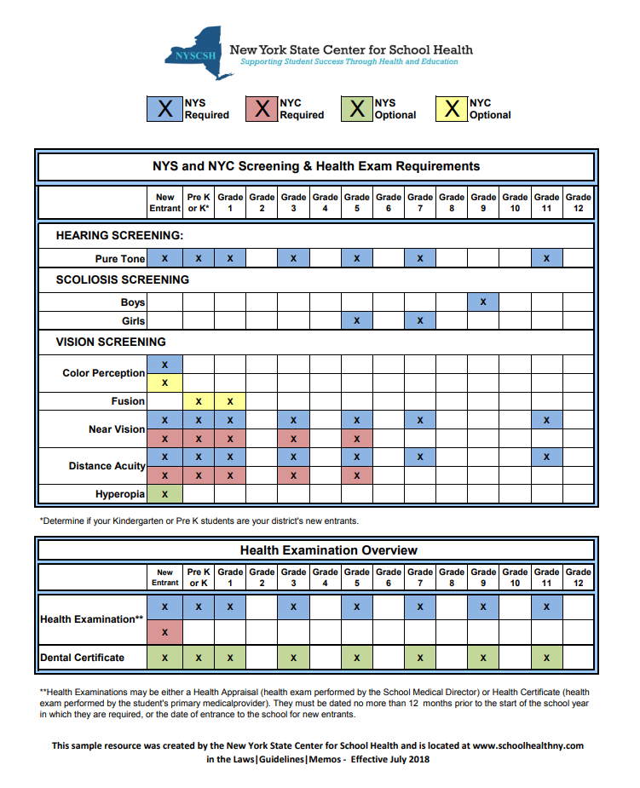
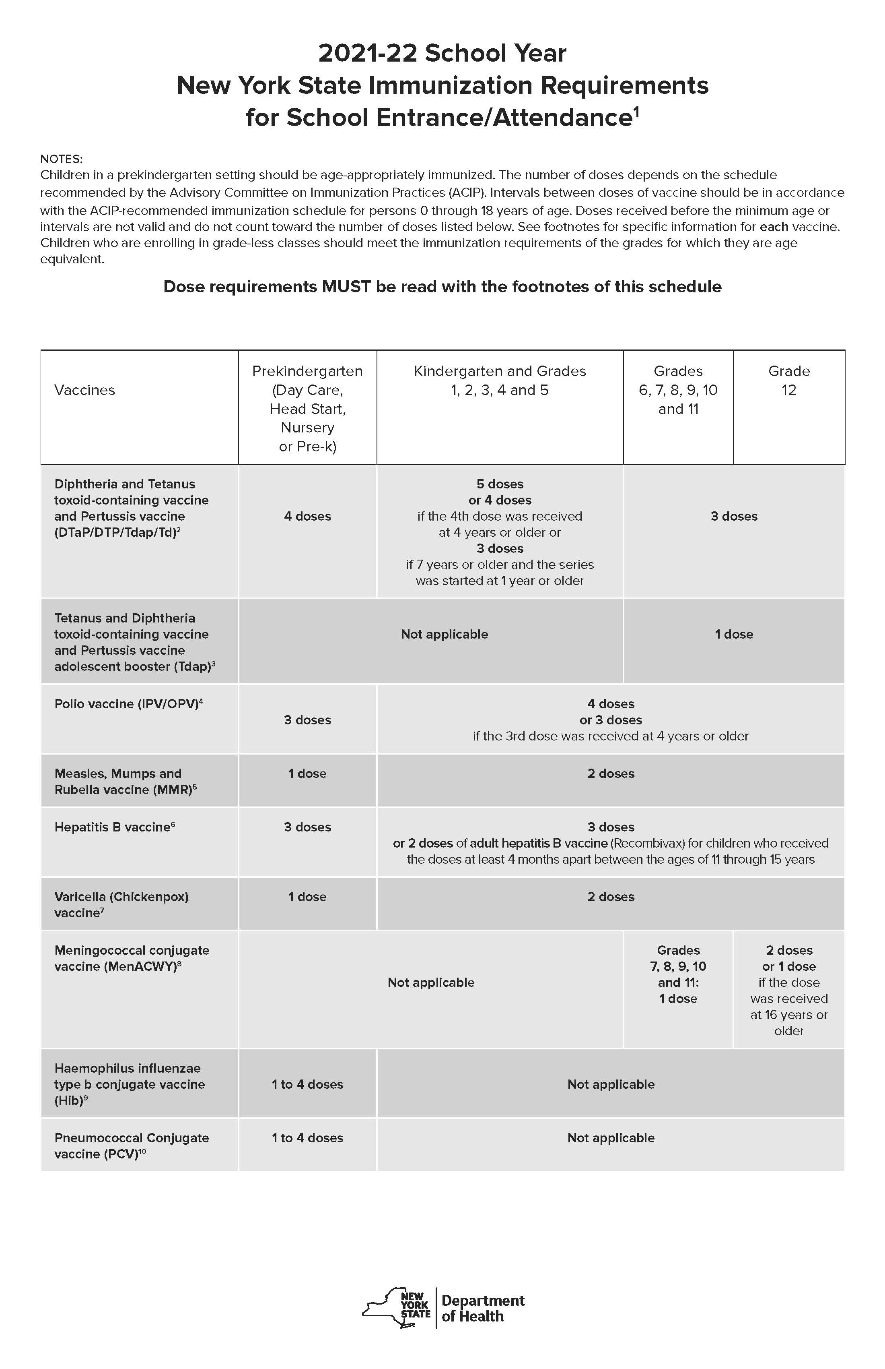
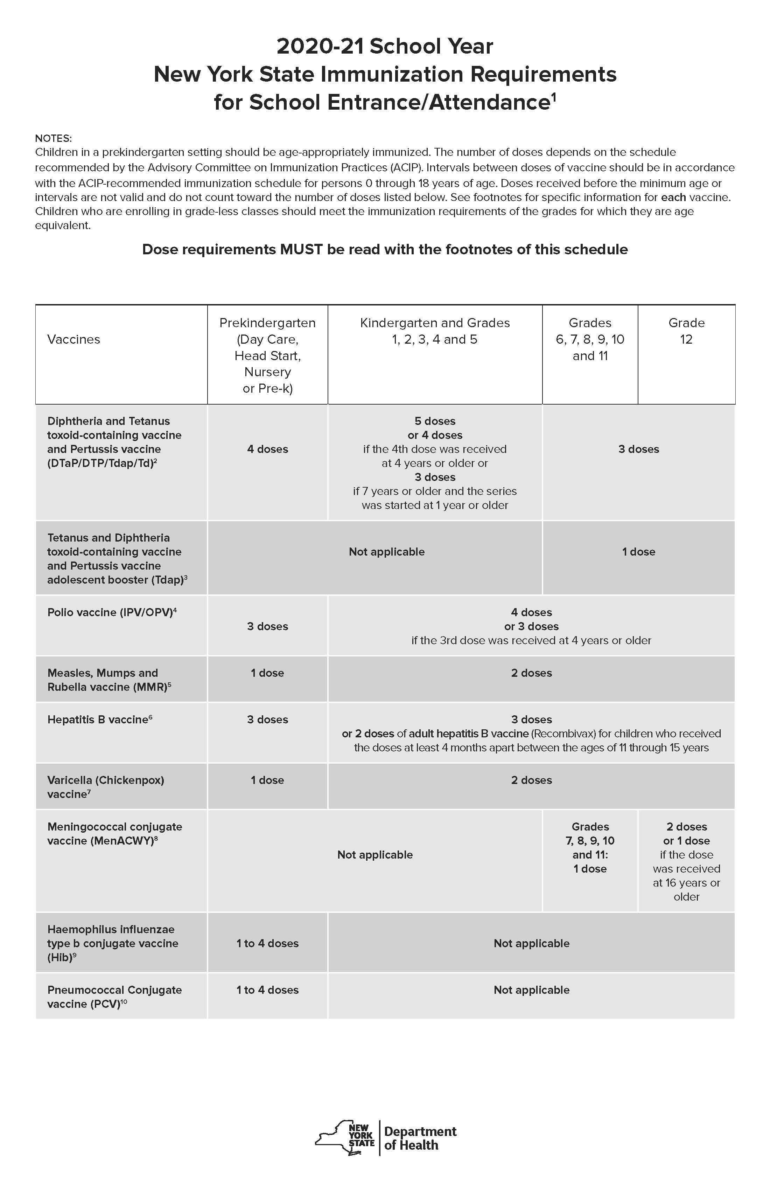

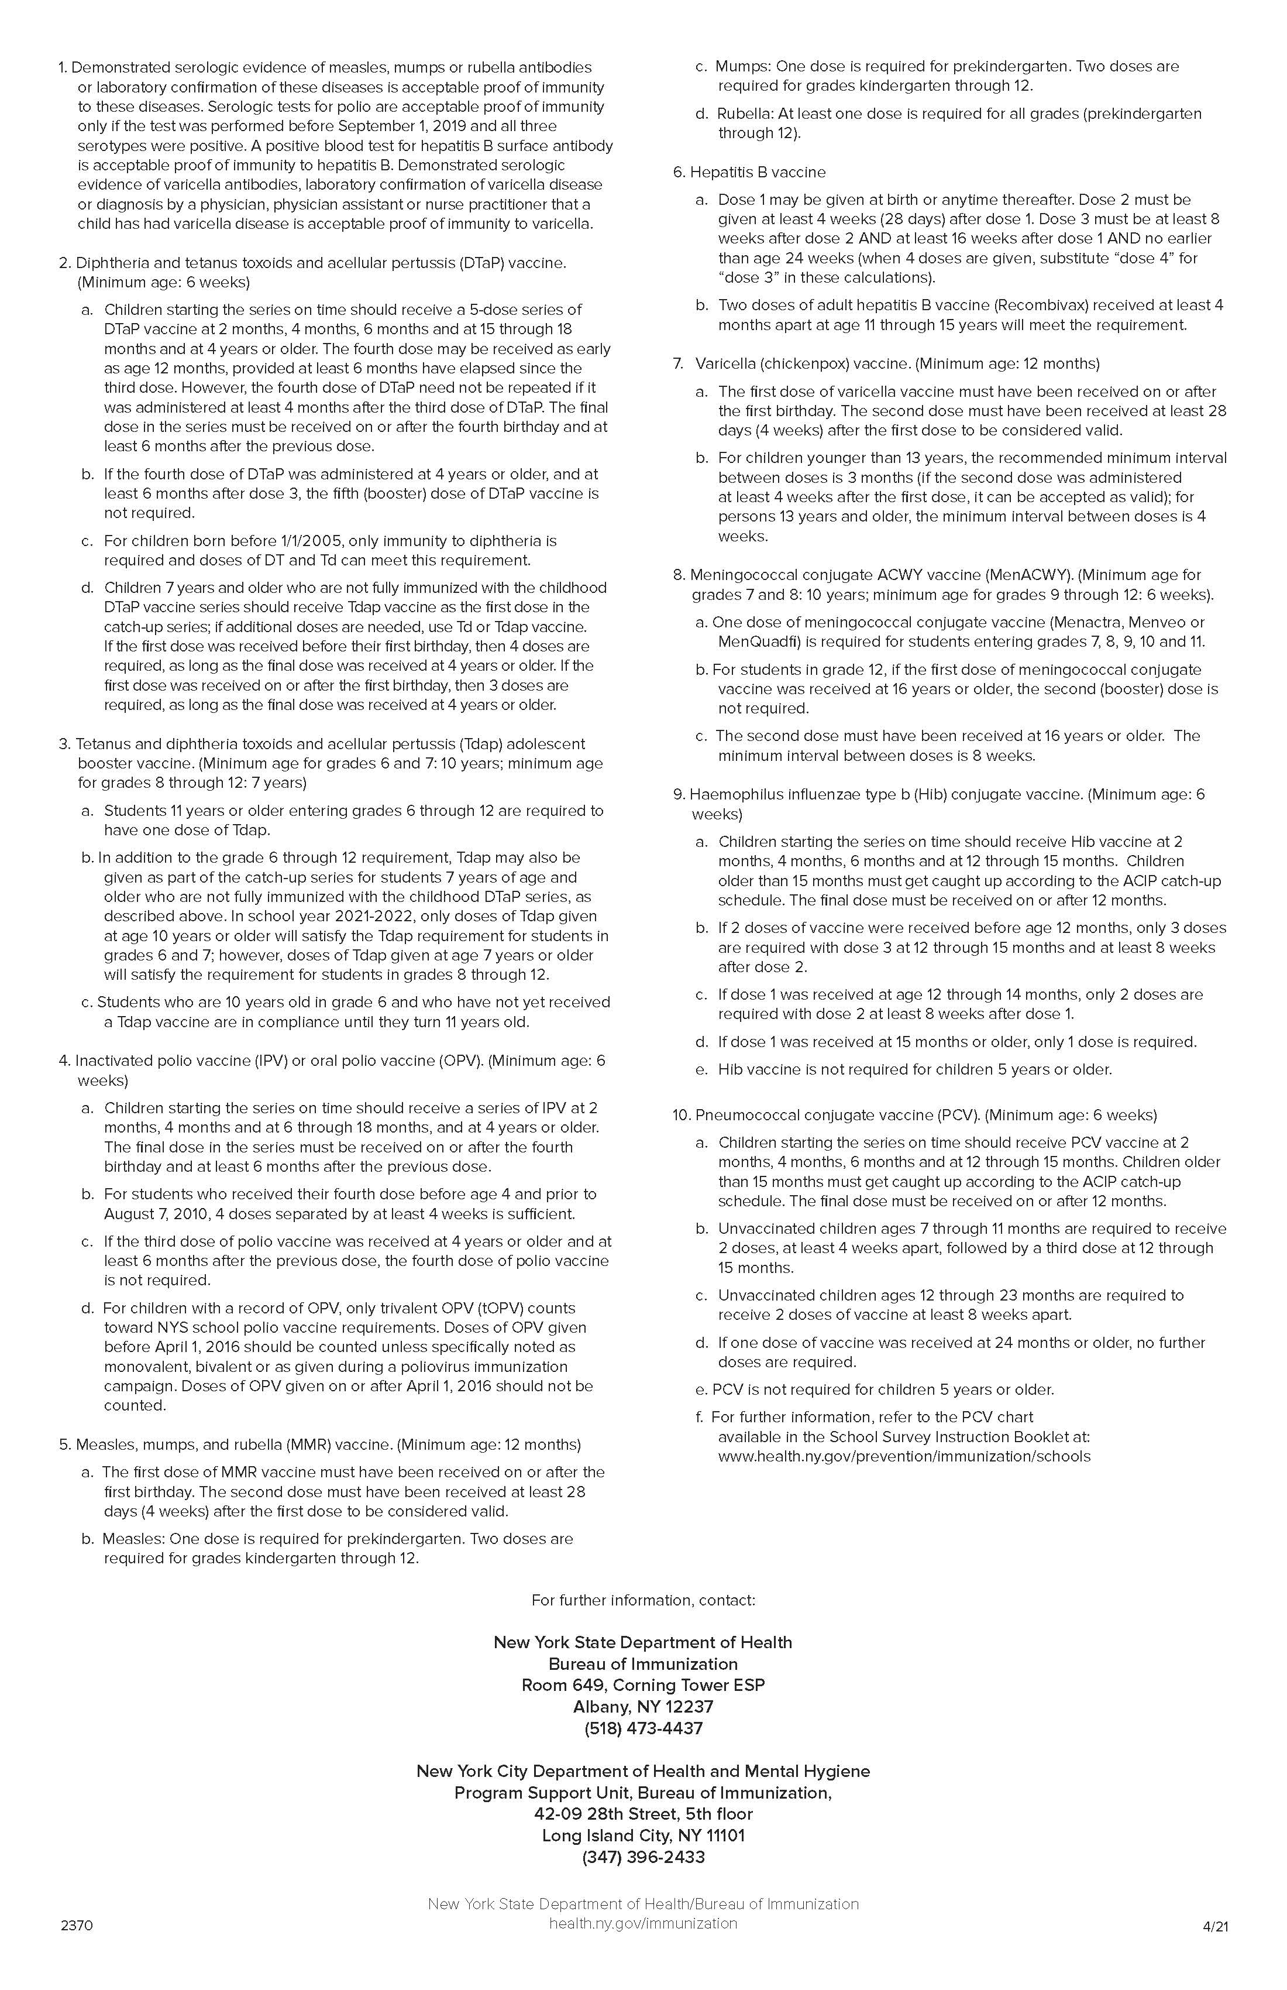
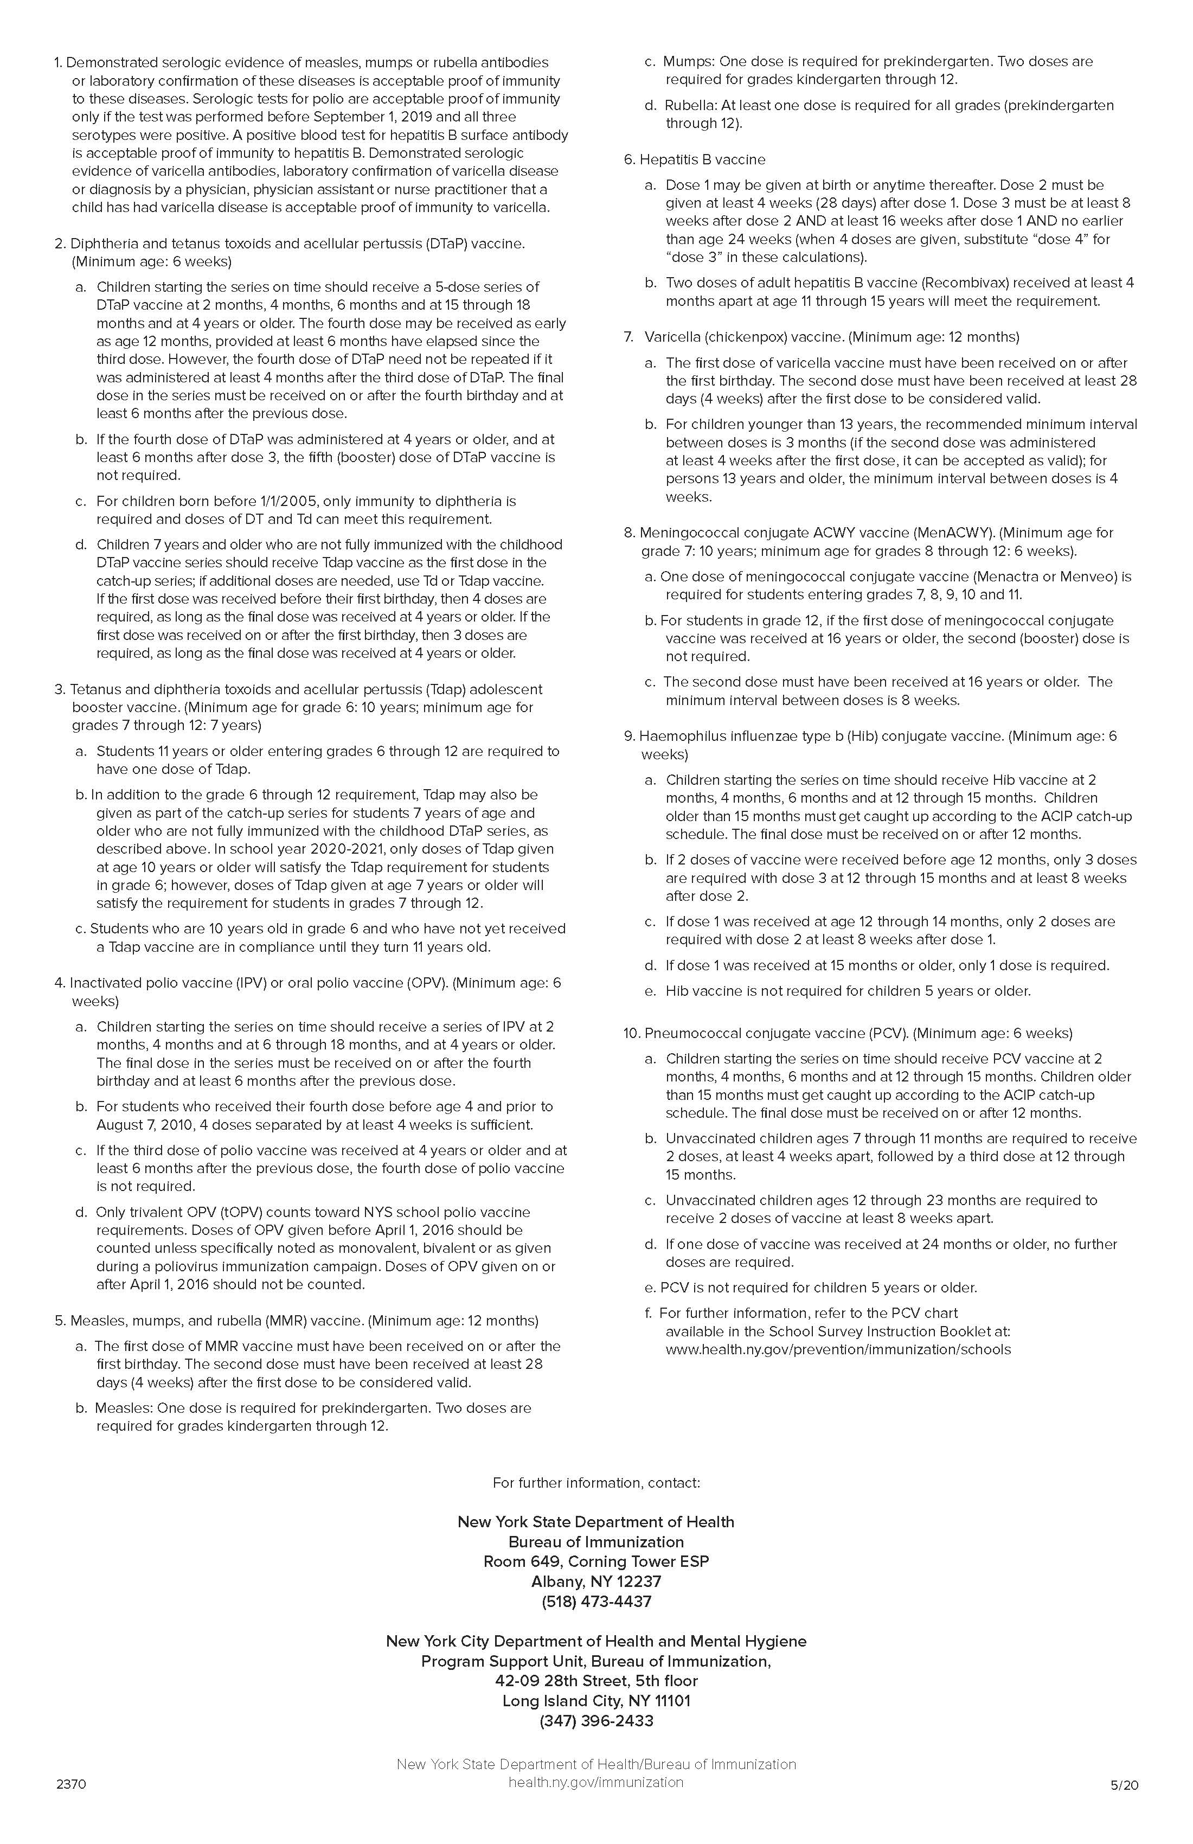

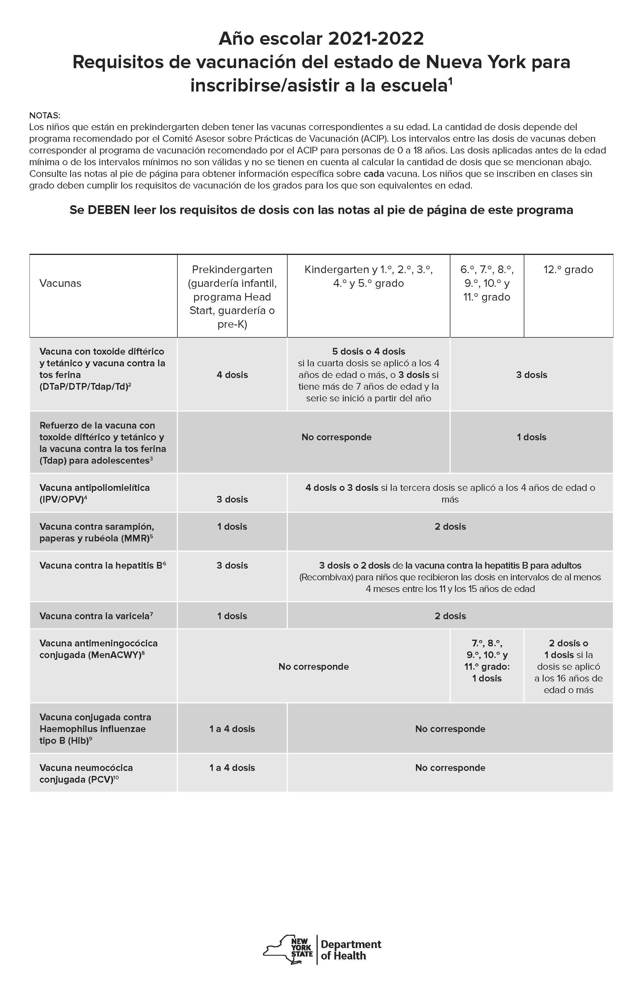
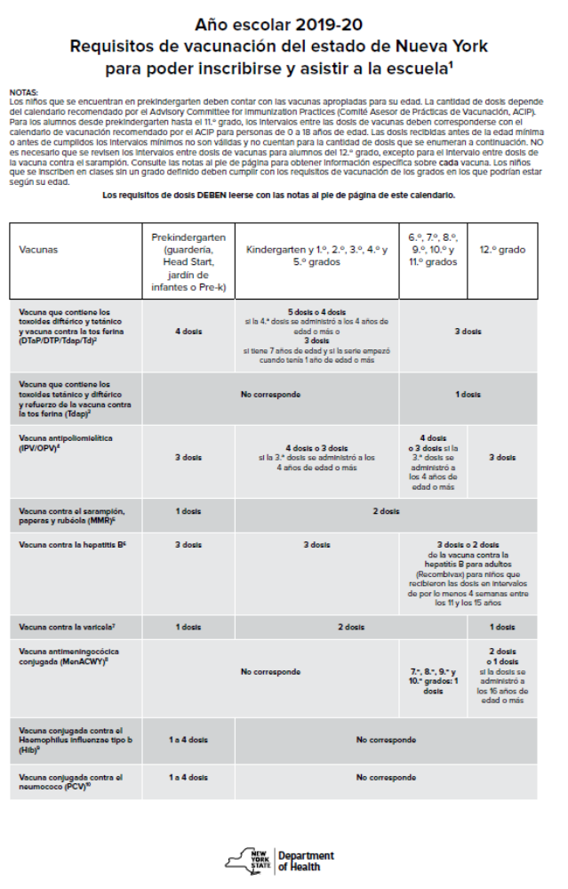

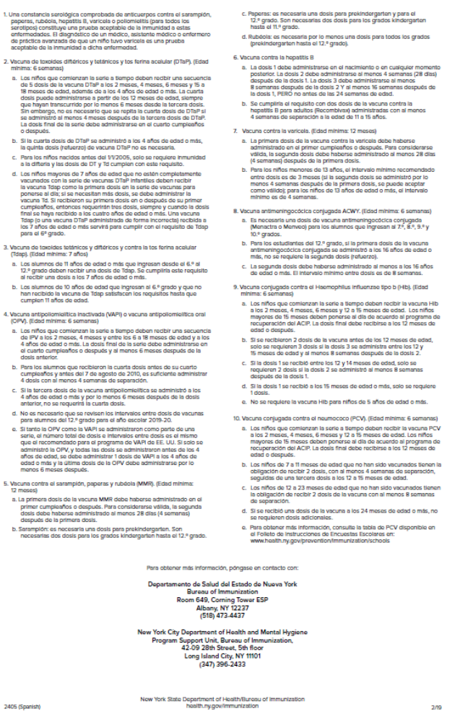

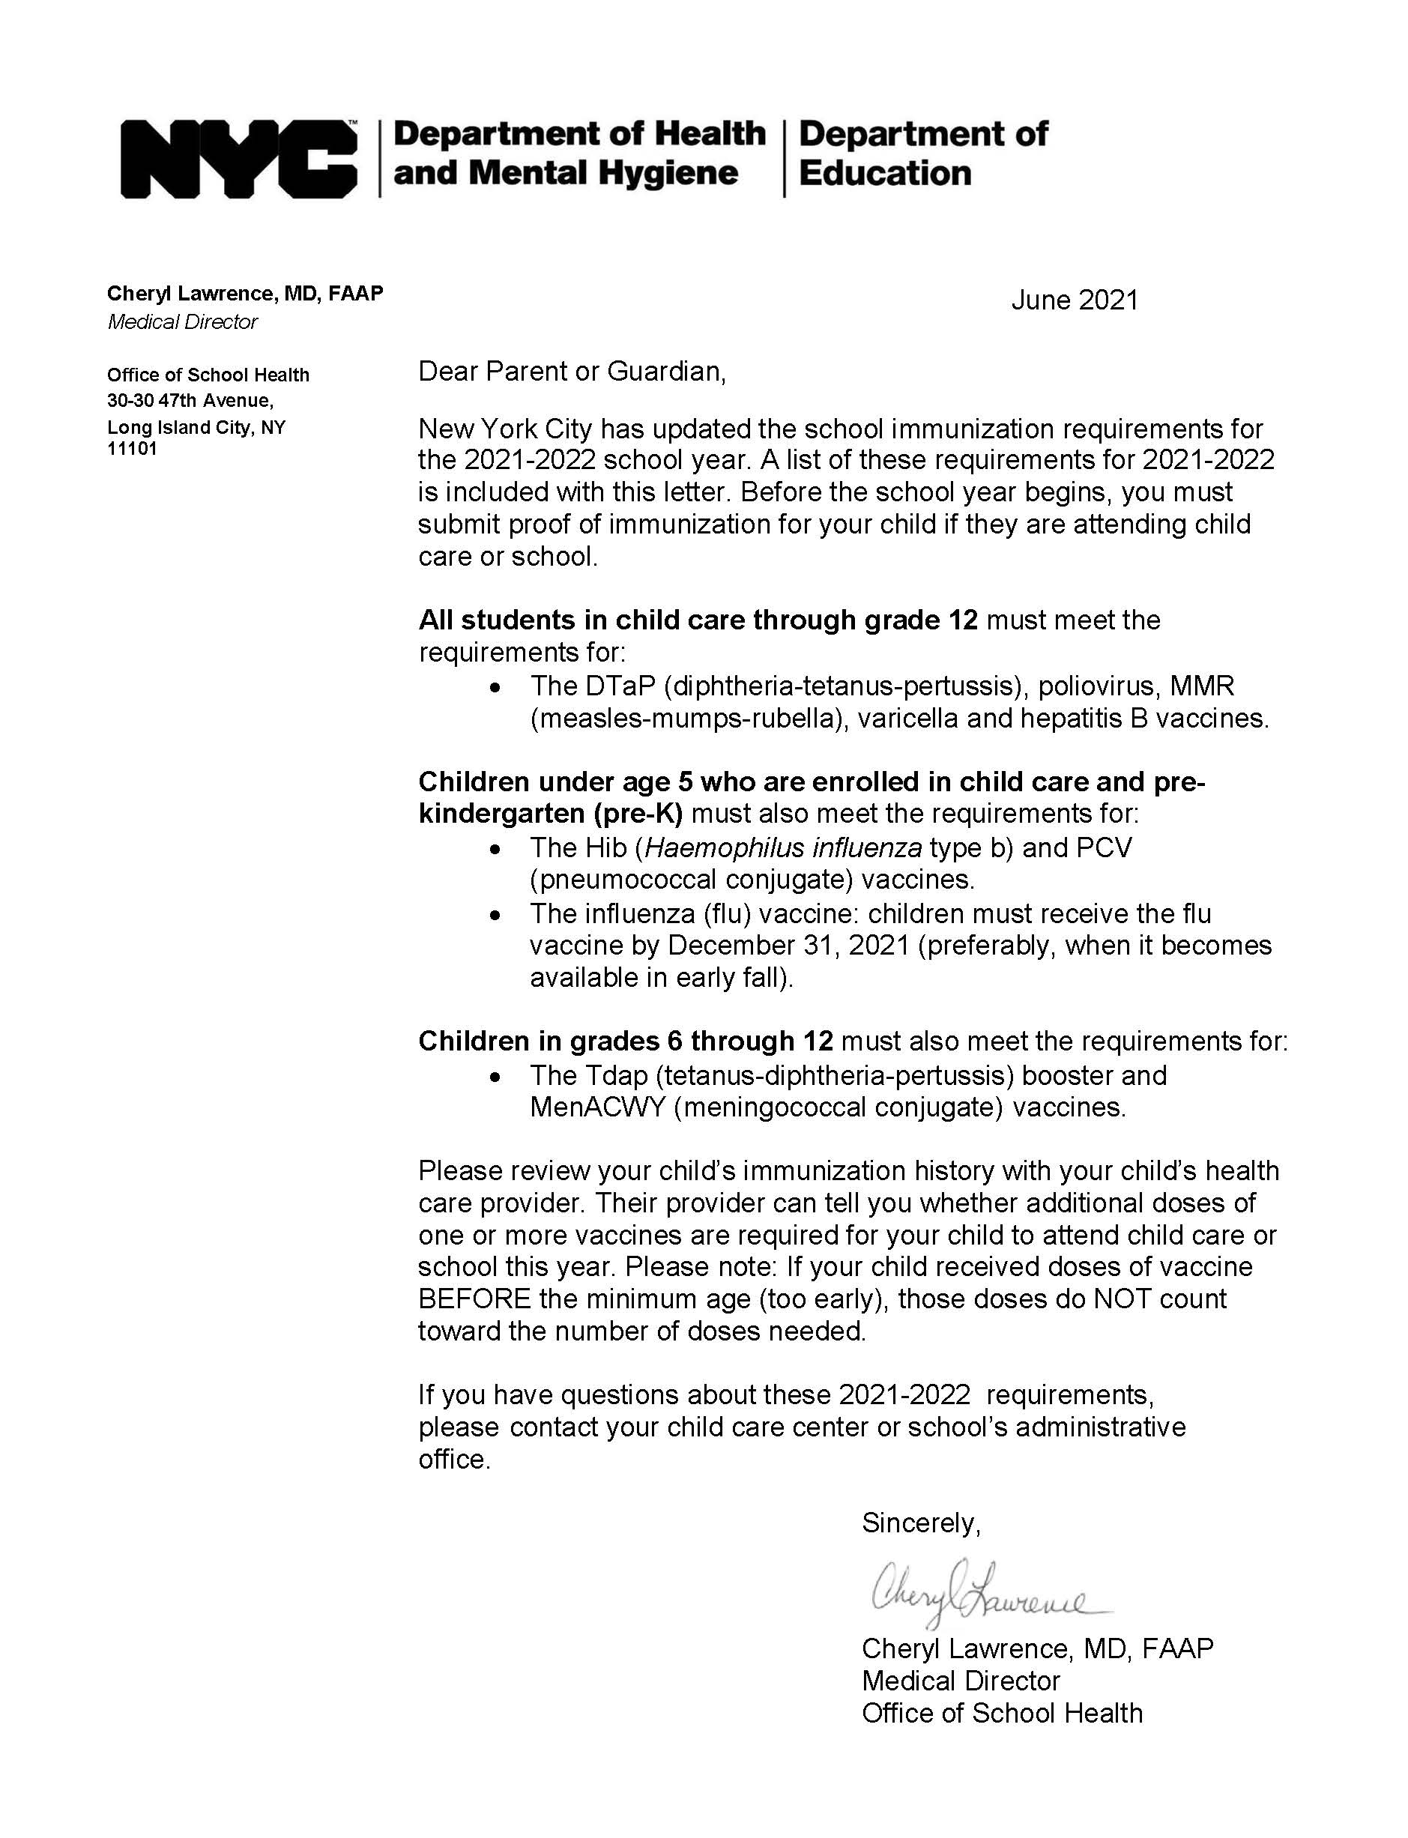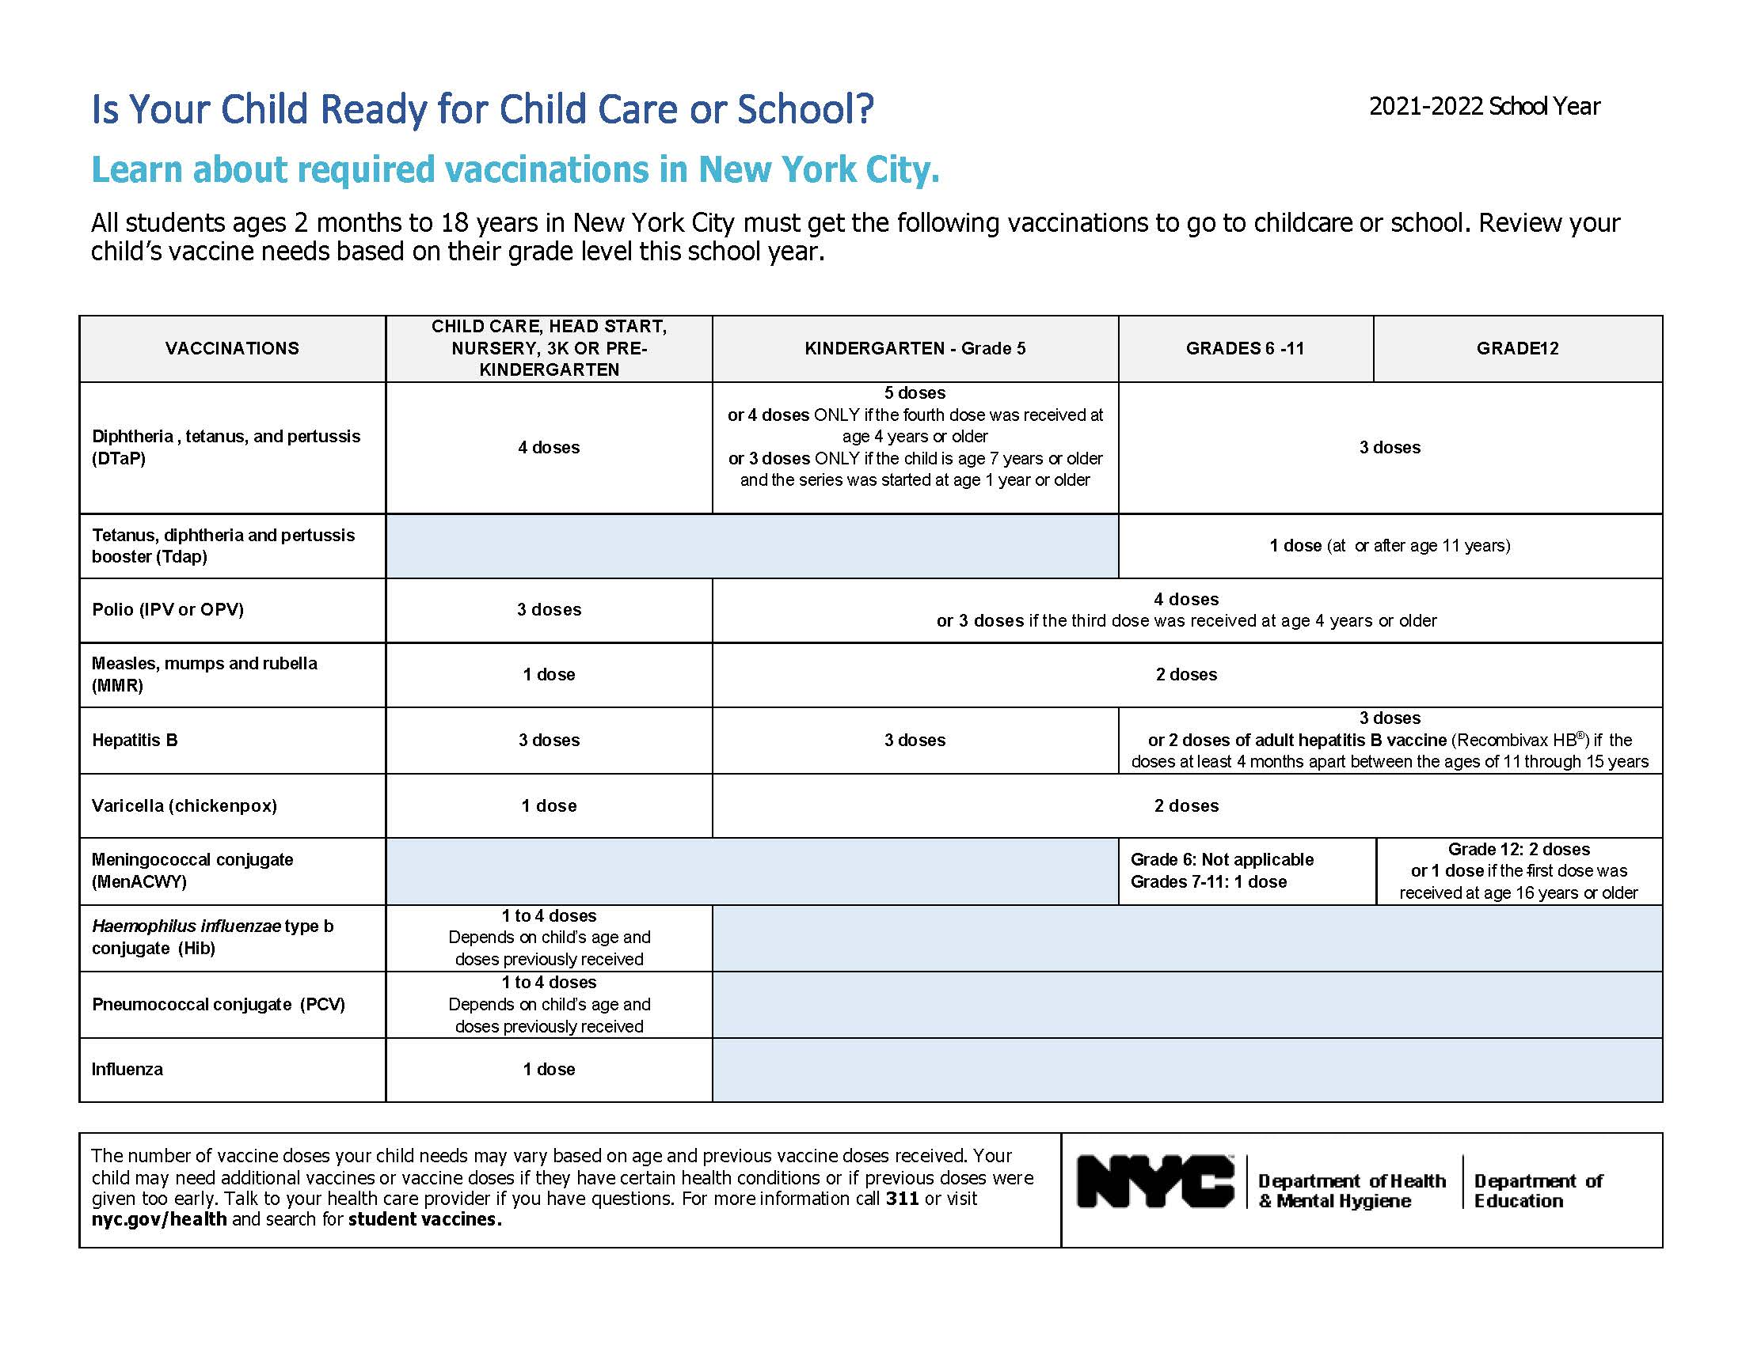

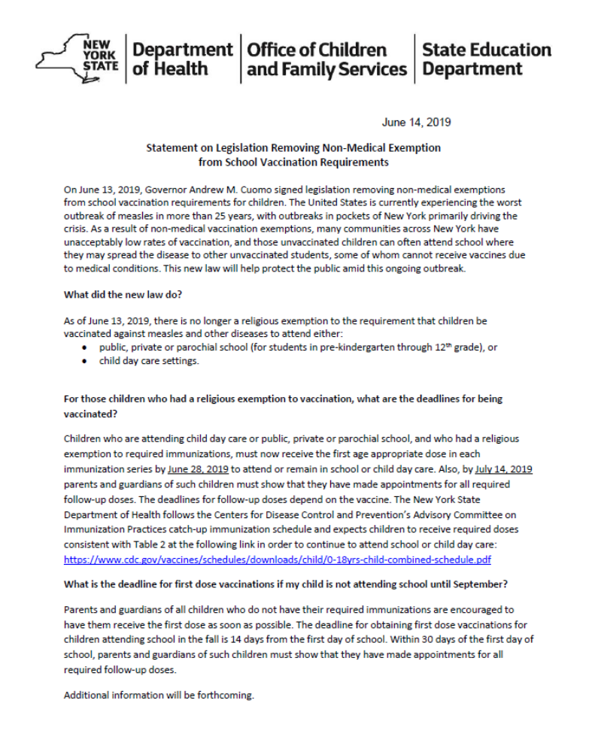

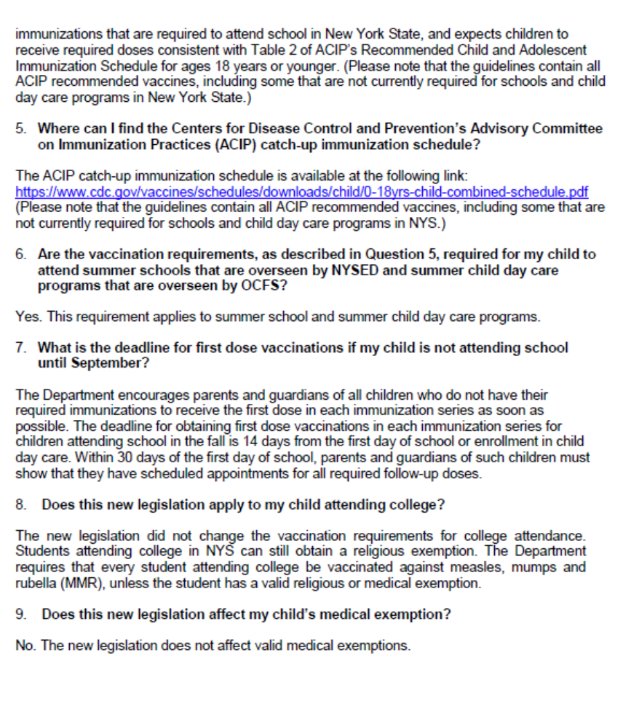

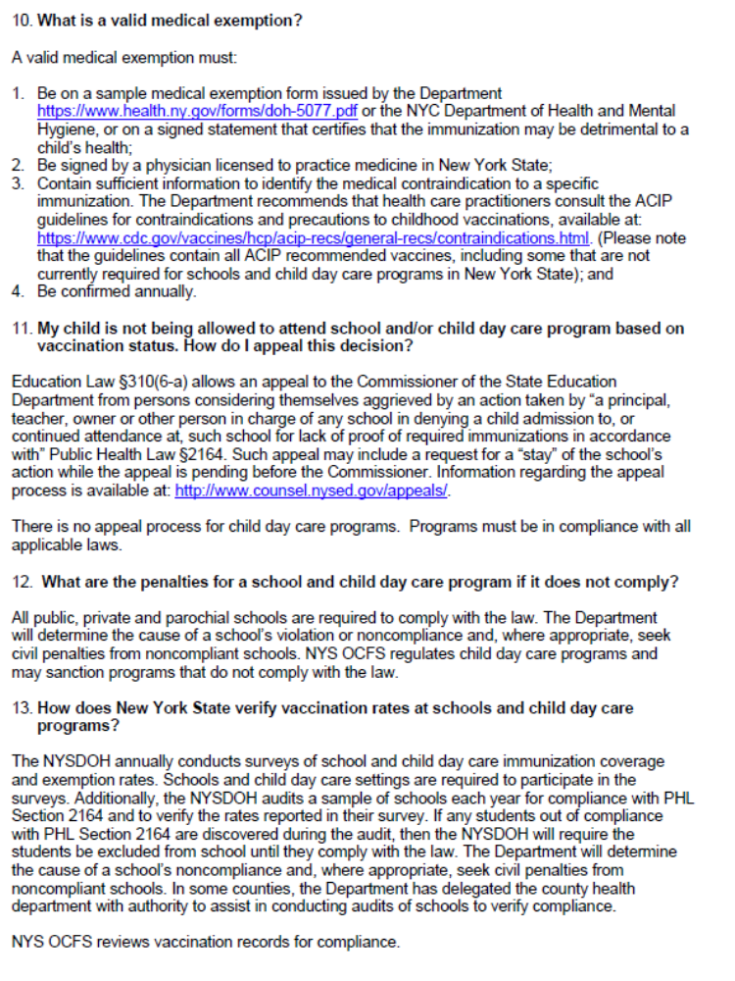

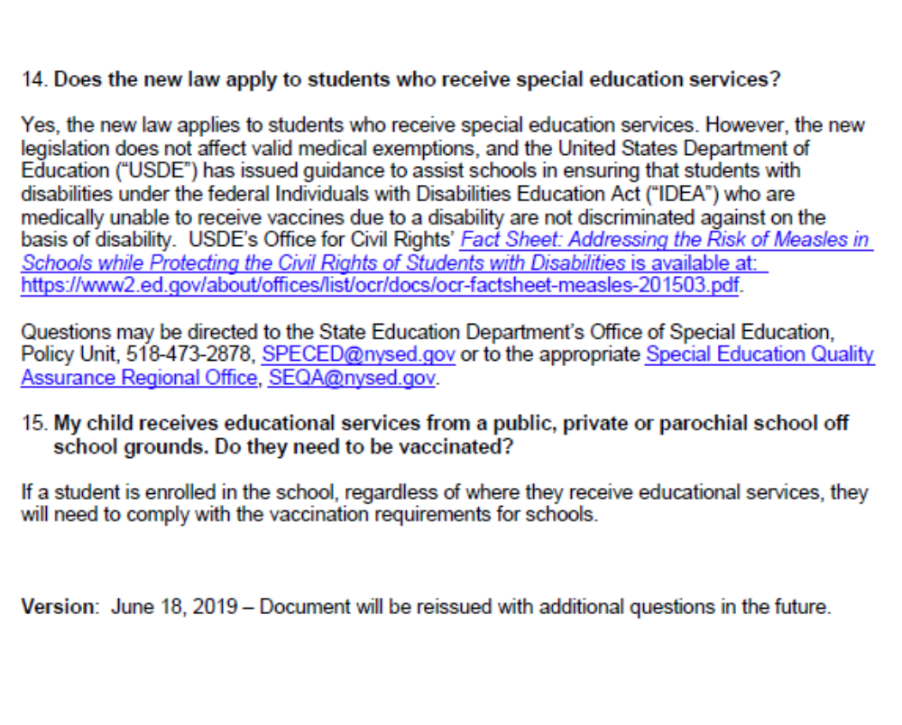

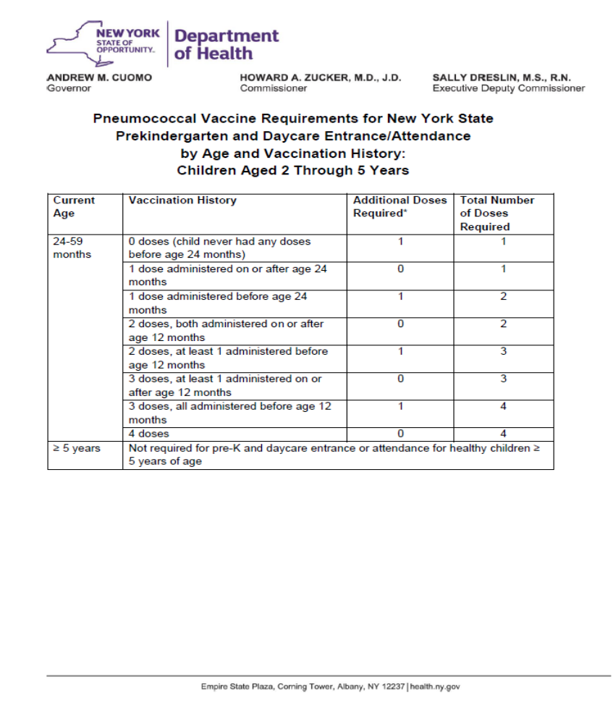
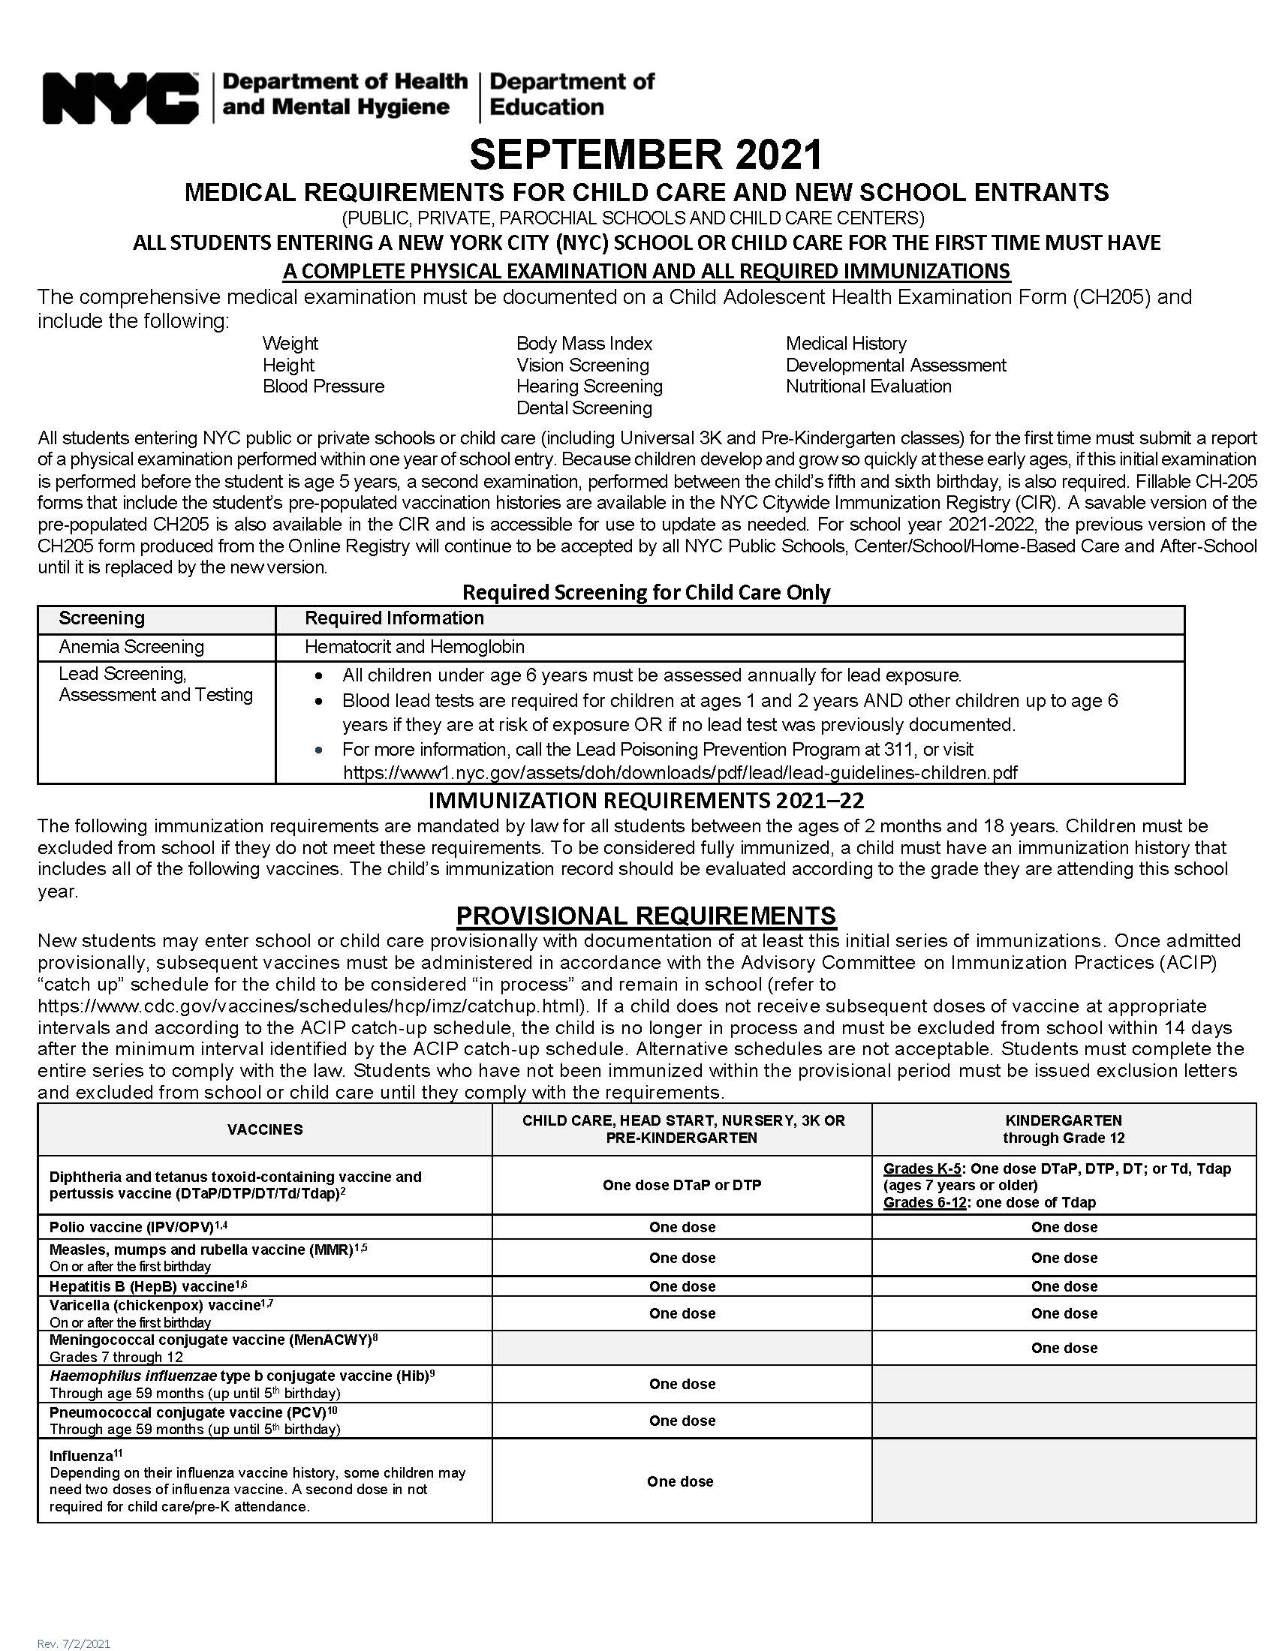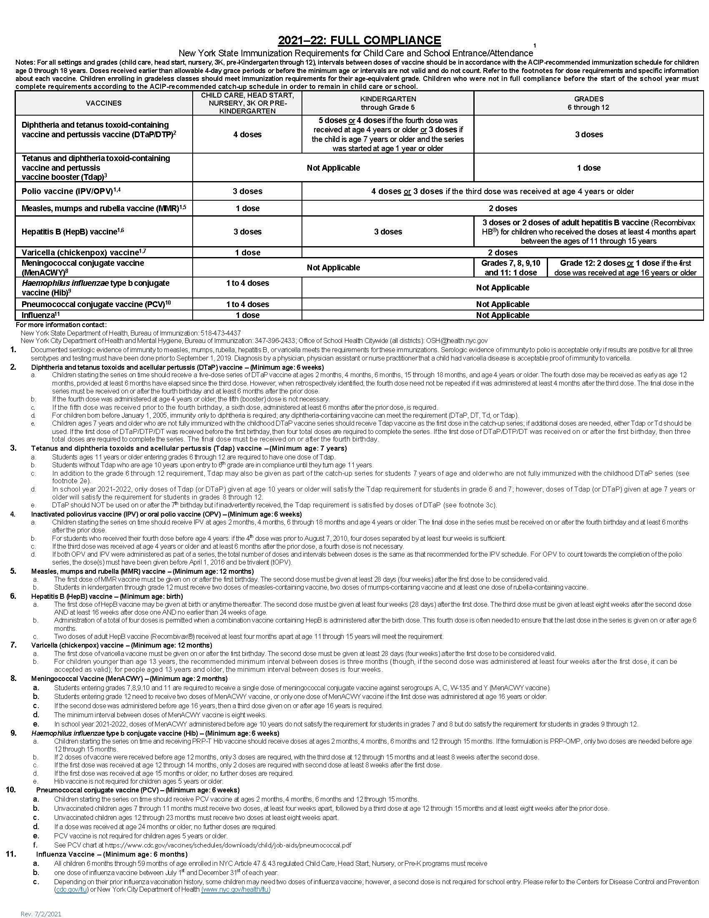
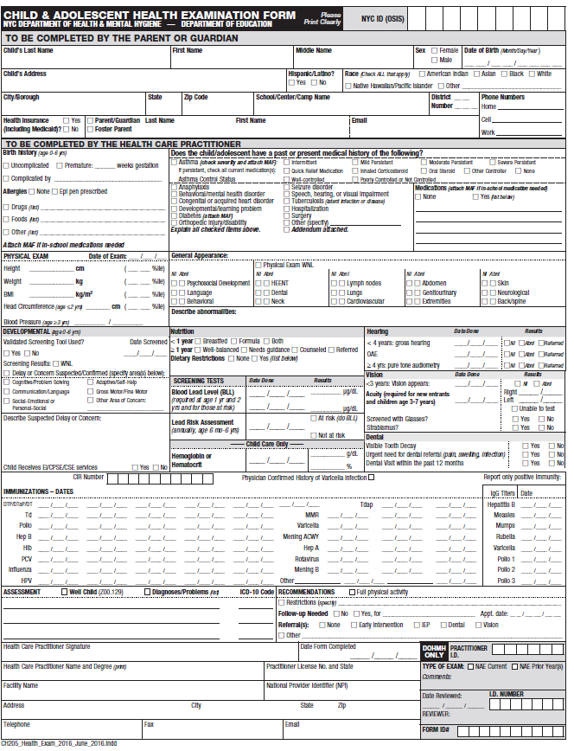
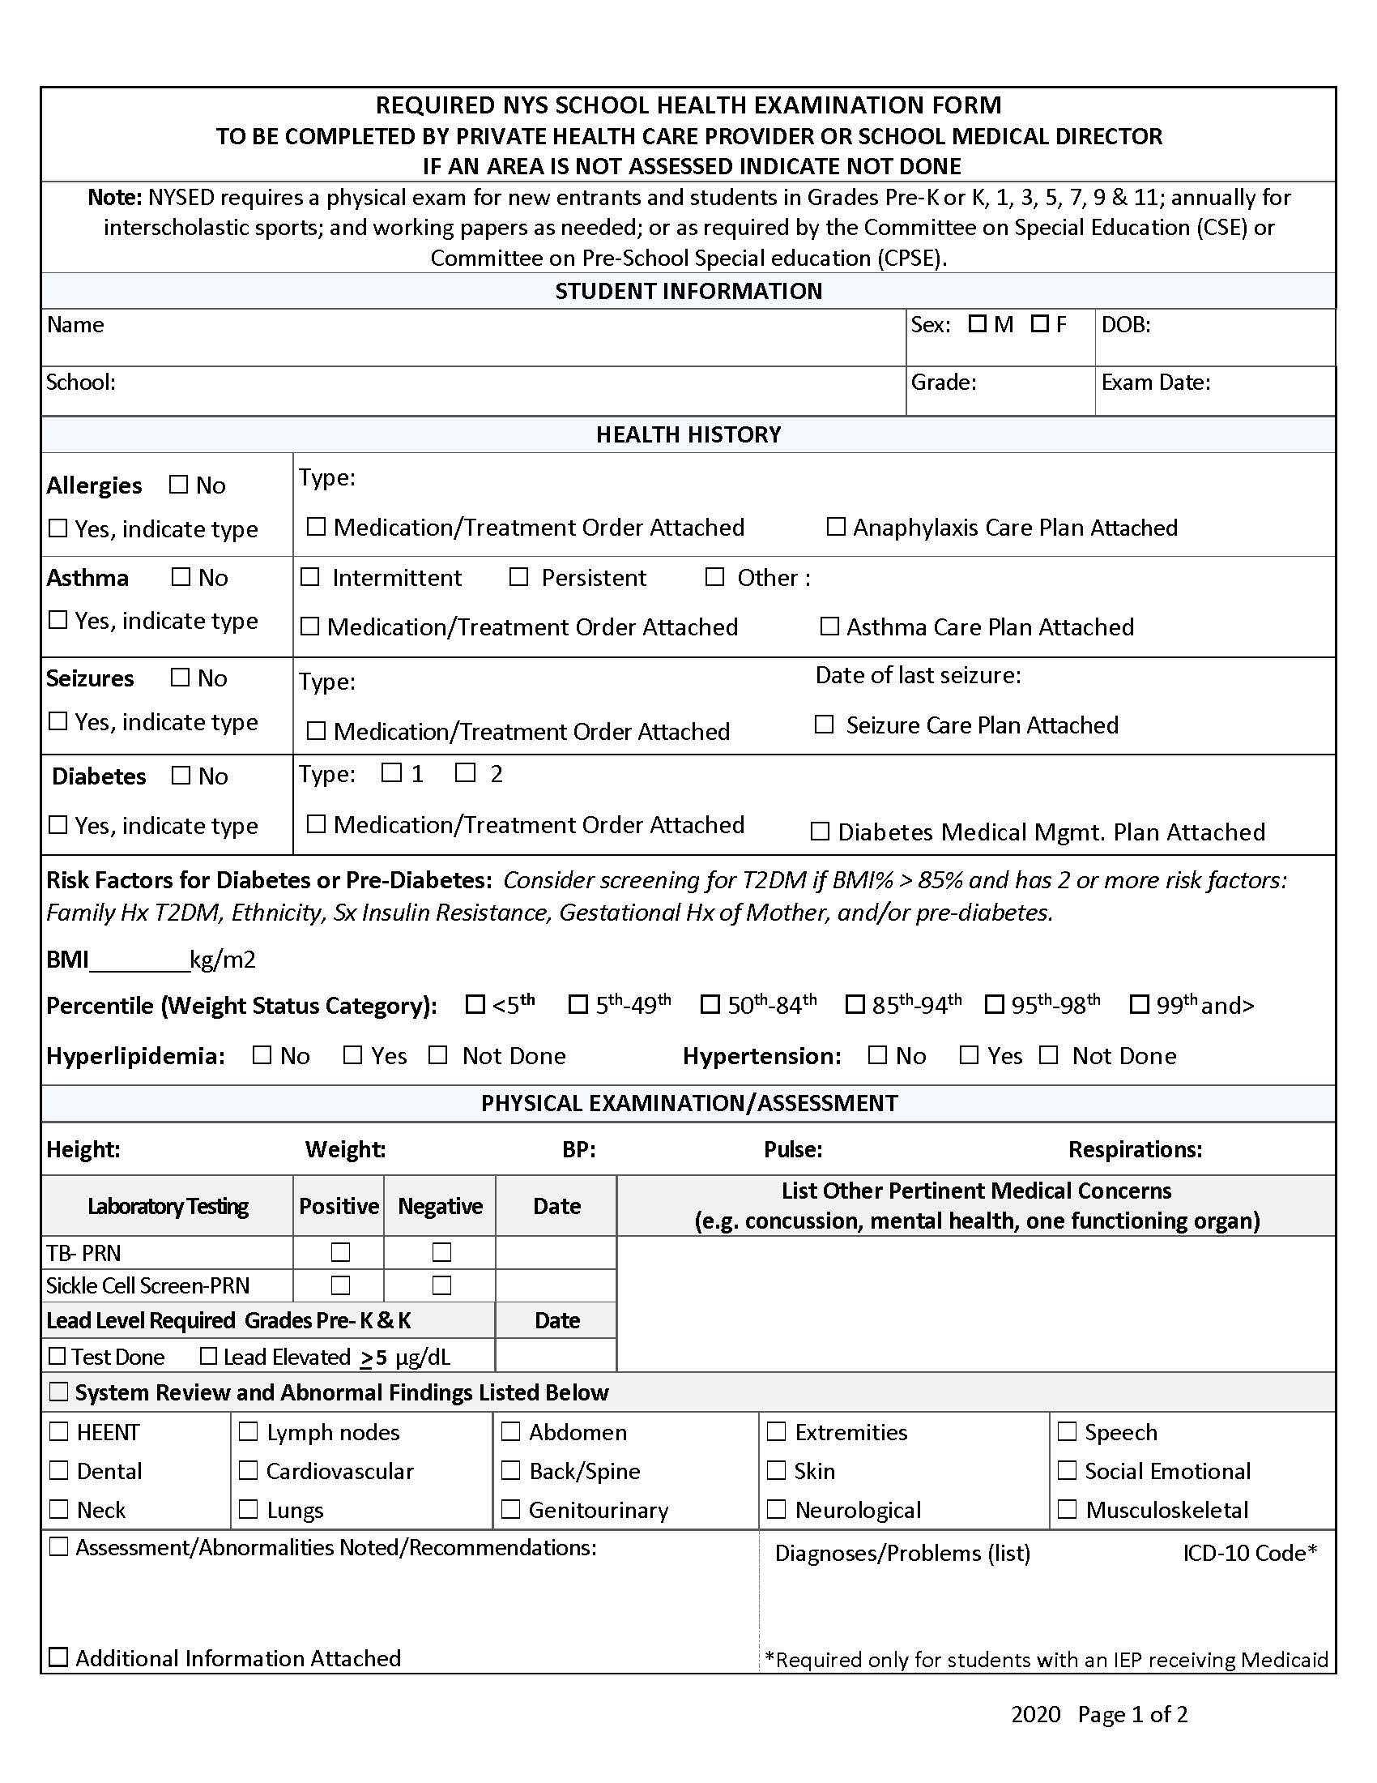
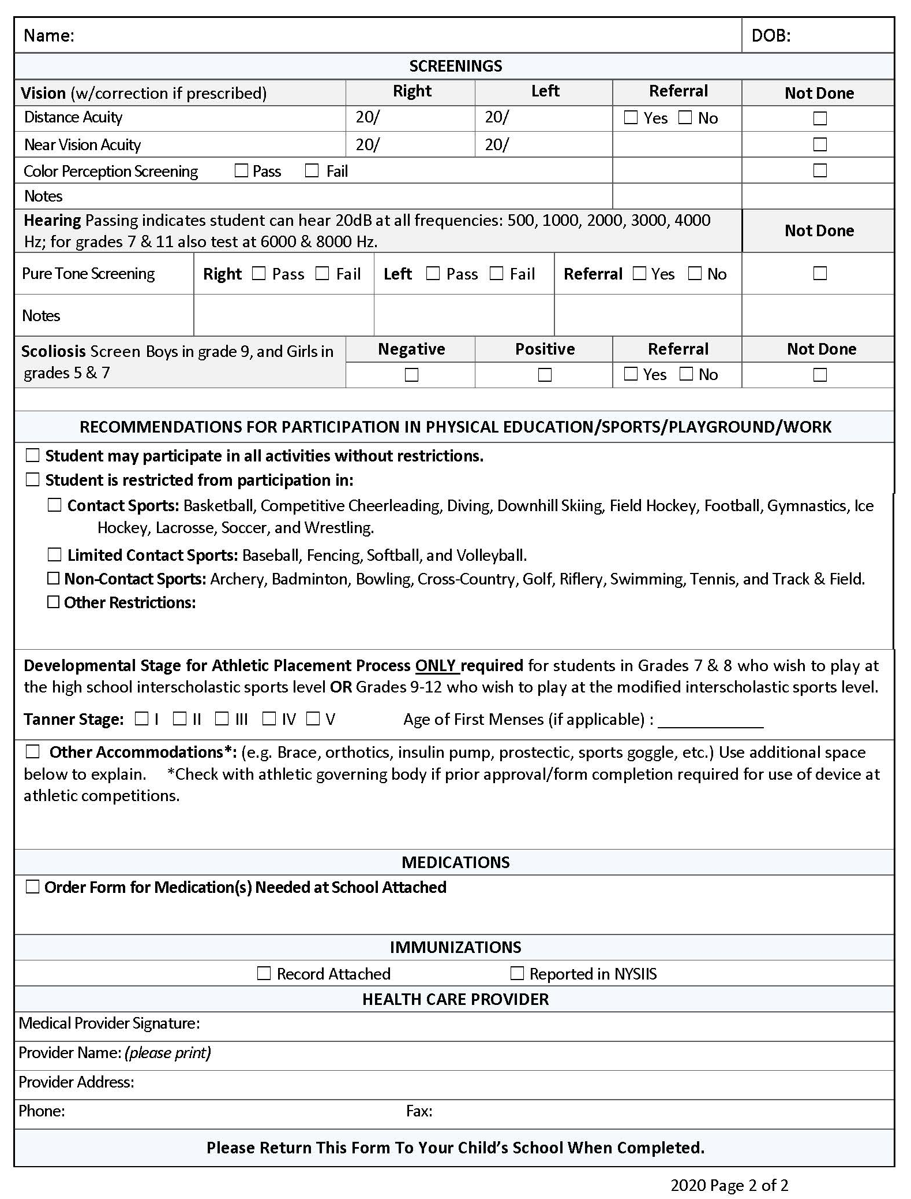
Data Privacy Consent Form
For Saint Ann School

Saint Ann School puts premium value to the privacy and security of personal data entrusted by its students and parents for legitimate purposes in connection with the Technology Use/Telecommunications Policy and any hardware and software used in connection therewith.
When we speak of “personal data”, the term includes the concepts of personal information, sensitive personal information, and privileged information. The first two are typically used to distinctively identify you.
Processing of Personal Data
- Collection of Information. We collect your personal data that you provide to us during your application for admission, information we acquire or generate upon enrollment, and during the course of your education with us in order to carry out the purposes associated with our Technology Use/Telecommunications Policy.

- Information you provide us during your application for admission. Upon application for admission, we collect information about personal circumstances and contact information, including, but not limited to, name, address, email address, telephone number and other contact details, family history, previous schools attended, academic performance, disciplinary record, medical record, etc.

- Information we acquire or generate upon enrollment and during the course of your education with us. Upon enrollment and during the course of your education with us, we collect information on your academic or curricular undertakings, the classes you enroll in and scholastic performance, attendance record, medical record, etc. We will also collect information for and in relation to co- curricular matters, such as outreach activities, as well as extra-curricular activities, such as membership in student organizations, leadership positions and participation and attendance in seminars, competitions and programs. We will also collect information in connection with any disciplinary incident, including accompanying sanctions that you may be involved in. We will also collect information in connection with your use of hardware and software provided to you during the course of your education with us, including, but not limited to, address, telephone number, email address, other unique identifier, passwords or PINs, and account credentials (e.g., username and password).

- Access to Information. Your personal information is accessed and used by us. We use and share your information as permitted or required by law to pursue our legitimate interests as an educational institution, including a variety of academic, administrative, historical, and statistical purposes. Some examples of situations when we may use your information to pursue our legitimate interests as an educational institution are as follows:

- evaluating applications for admission;

- processing confirmation of incoming students and transfer students in preparation for enrollment;

- recording, generating and maintaining student records of academic, co-curricular and extra- curricular progress;

- establishing and maintaining student information systems;

- maintaining directories and records;

- compiling and generating reports for statistical and research purposes;

- providing services such as health, counseling, information technology, library, sports/recreation, transportation, safety and security;

- managing and controlling access to campus facilities and equipment;

- communicating official school announcements; sharing marketing and promotional materials regarding school-related functions, events, projects and activities; and

- soliciting your participation in research and non-commercial surveys.

- Sharing of Information. Some examples of when we may share or disclose your personal information to others include:

- sharing of information to persons, including parents, guardians or next of kin, as required by law or on a need-to-know basis as determined by the school to promote your best interests, or protect your health, safety and security, or that of others;

- providing academic institutions, companies, government agencies, private or public corporations, or the like, upon their request, with scholastic ranking information or certification of good moral character for purposes of admission;

- reporting and/or disclosing information to government bodies or agencies (e.g., Commission on Higher Education, Department of Education); and

- conducting research or surveys for purposes of institutional development; and

- sharing of information to various third party vendors who provide services associated with our Technology Use / Telecommunications Policy and any hardware and software used in connection therewith.

Data Protection

We shall implement reasonable and appropriate organizational, physical, and technical security measures for the protection of personal data which we collected. The security measures shall aim to maintain the availability, integrity, and confidentiality of personal data and are intended for the protection of personal data against any accidental or unlawful destruction, alteration, and disclosure, as well as against any other unlawful processing. We only permit your data to be accessed or processed by authorized personnel who hold such information under strict confidentiality, including all third-party vendors.
Any data security incident or breach that comes to the knowledge of us will be recorded and reported as required by law. We will take all necessary and reasonable steps to address such incident or breach and mitigate any negative effect of such incident or breach. If there is strong suspicion that an incident affects your personal information, we will notify you of such incident in an appropriate manner.
Consent
I have read this form, understood its contents and consent to (a) the collection, use, processing and transfer by [SCHOOL] of certain personal information about you (the “Data”); (b) any transfer of Data by any such authorized person for the purposes of implementing, administering and managing the purposes outlined above; (c) the use of such Data by any such authorized person for such purposes; and (d) the transfer to and retention of such Data by third parties in connection with such purposes. I further agree and acknowledge that while [SCHOOL] has taken all necessary and reasonable steps to ensure that all third parties protect such Data, [SCHOOL] has no control over how the third party will use or disseminate my information. I agree to release and hold harmless [SCHOOL], its representatives, officers, employees, contractors, agents, and assignees, from any and all claims of action or damages of any kind arising from, or in any way connected to, the release or use of any information or records by any third party pursuant to this form and as allowed by all applicable laws.

Complete Name of Student/Child/Ward: ___________________________________
Signature of Student: _________________________________________________
Date: ___________________________

If below 18 years old,
As the parent of this student, I have read the data privacy consent form, understood its contents and provide consent to use the personal information collected as outlined and in accordance with this form. I hereby give permission to use the personal information collected as outlined and in accordance with this form and certify that I have reviewed this information with my child.
Parent’s or guardian’s name (please print): ___________________________________
Parent/Guardian Signature: ______________________________ Date:____________
Please return as of September 16, 2022.

